Rotherhithe Primary School – History
 | Year 6 |  | Topic: Local history
What I already know. |  | LONDON HYDRAULIC POWER COMPANY FORMER PUMPING STATION
Skills  - Develop a chronologically knowledge and understanding of the local history of Rotherhithe.  - Contrast trends over time about local history.  - Discuss historically valid questions about change, cause, similarity and difference, and significance.  - Understand how our knowledge of the past is constructed from a range of sources „  - Be aware of different views about the local people/events studied and be able to give some reasons why different versions of the past exist  - Evaluate a range of historical sources |  | 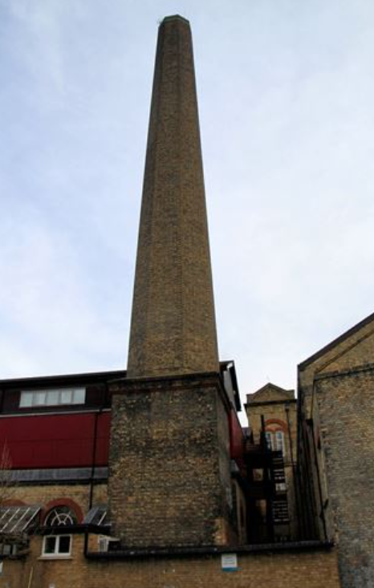
What I will know by the end of the unit. |  | Heritage list
Skills  - Develop appropriate use of historical terms about local history.  - Address and sometimes devise historically valid questions about change, cause, similarity and difference, and significance.  - Construct informed responses by selecting and  - Identify anachronism, be aware of different views about the local people/events studied and be able to give some reasons why different versions of the past exist  - Evaluate a range of historical sources and make perceptive deductions about the reliability of sources in answering local historical questions.  - Understand change and continuity, and the significance of local people.„ |  | 

