Rotherhithe Primary School – History
 | Year 5 |  | Topic: Local history
What I already know. |  | TURNTABLE AND MACHINERY OF FORMER SWING ROAD BRIDGE, REDRIFF ROAD
Skills  - Develop appropriate use of historical terms about local history.  - Select and organise relevant local historical information.  - Understand how our knowledge of the past is constructed from a range of sources.„ |  | 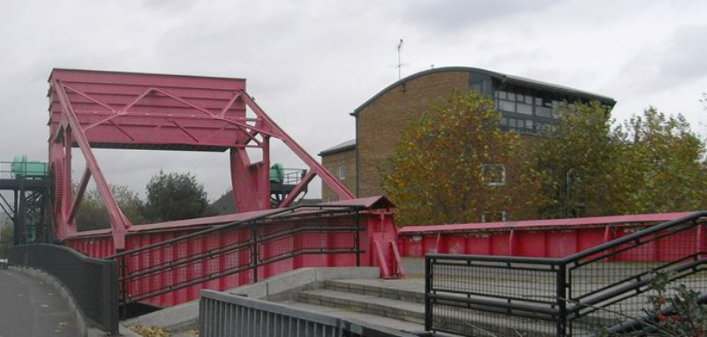
What I will know by the end of the unit. |  | Heritage list
Skills  - Develop a chronologically knowledge and understanding of the local history of Rotherhithe.  - Contrast trends over time about local history.  - Discuss historically valid questions about change, cause, similarity and difference, and significance.  - Construct informed responses by selecting and organising relevant local historical information  - Understand how our knowledge of the past is constructed from a range of sources „  - Be aware of different views about the local people/events studied and be able to give some reasons why different versions of the past exist  - Evaluate a range of historical sources |  | 

