Rotherhithe Primary School – History
 | Year 3 |  | Topic: Local history
What I already know. |  | AIR SHAFT TO THE ROTHERHITHE TUNNEL
Skills  - Develop an awareness of Rotherhithe’s past, using common words and phrases relating to the passing of time.  - Shows knowledge of where the people and events about their local history fit within a chronological framework  - To identify similarities and differences between ways of life in Rotherhithe through different periods.  - Use a wide vocabulary of everyday historical terms linked to local history.  - To ask and answer questions, choosing and using parts of stories and other sources to show that they know and understand key features of events from local history. |  | 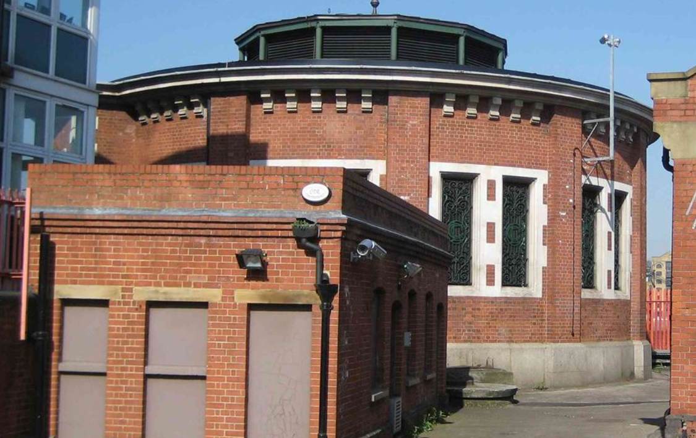
What I will know by the end of the unit. |  | Heritage list
Skills  - Develop a knowledge and understanding of the local history of Rotherhithe.  - Develop appropriate use of historical terms about local history.  - Discuss questions about change, cause, similarity and difference.  - Organise relevant local historical information.  - Understand how our knowledge of the past is constructed from a range of sources. |  | 

