Rotherhithe Primary School – History
 | Year 2 |  | Topic: Local history
What I already know. |  | CHURCH OF ST MARY ROTHERHITHE
Skills  - Shows knowledge of people and events about their local history  - To identify similarities and differences between ways of life in Rotherhithe  - Use vocabulary linked to local history.  - To ask and answer questions, about stories linked to events from local history. |  | 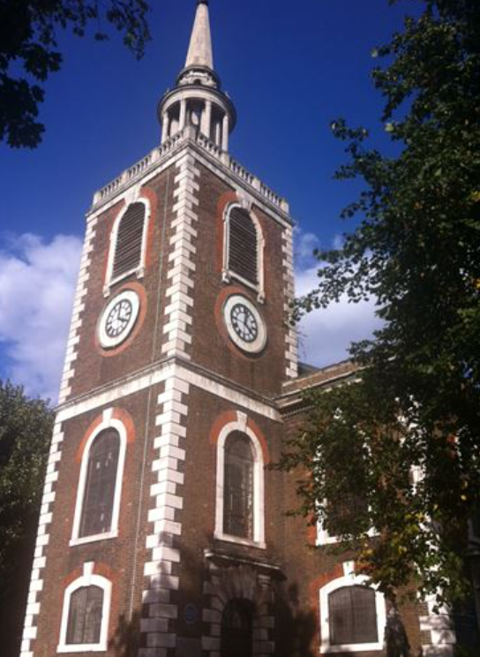
What I will know by the end of the unit. |  | Heritage list
Skills  - Develop an awareness of Rotherhithe’s past, using common words and phrases relating to the passing of time.  - Shows knowledge of where the people and events about their local history fit within a chronological framework  - To identify similarities and differences between ways of life in Rotherhithe through different periods.  - Use a wide vocabulary of everyday historical terms linked to local history.  - To ask and answer questions, choosing and using parts of stories and other sources to show that they know and understand key features of events from local history. |  | 

