Rotherhithe Primary School | History Knowledge Organiser |  |  | Hidden figures | Year 4
Mary Jackson |  | Katherine Johnson |  | Dorothy Vaughn | Christine Darden
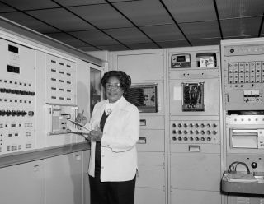 |  | 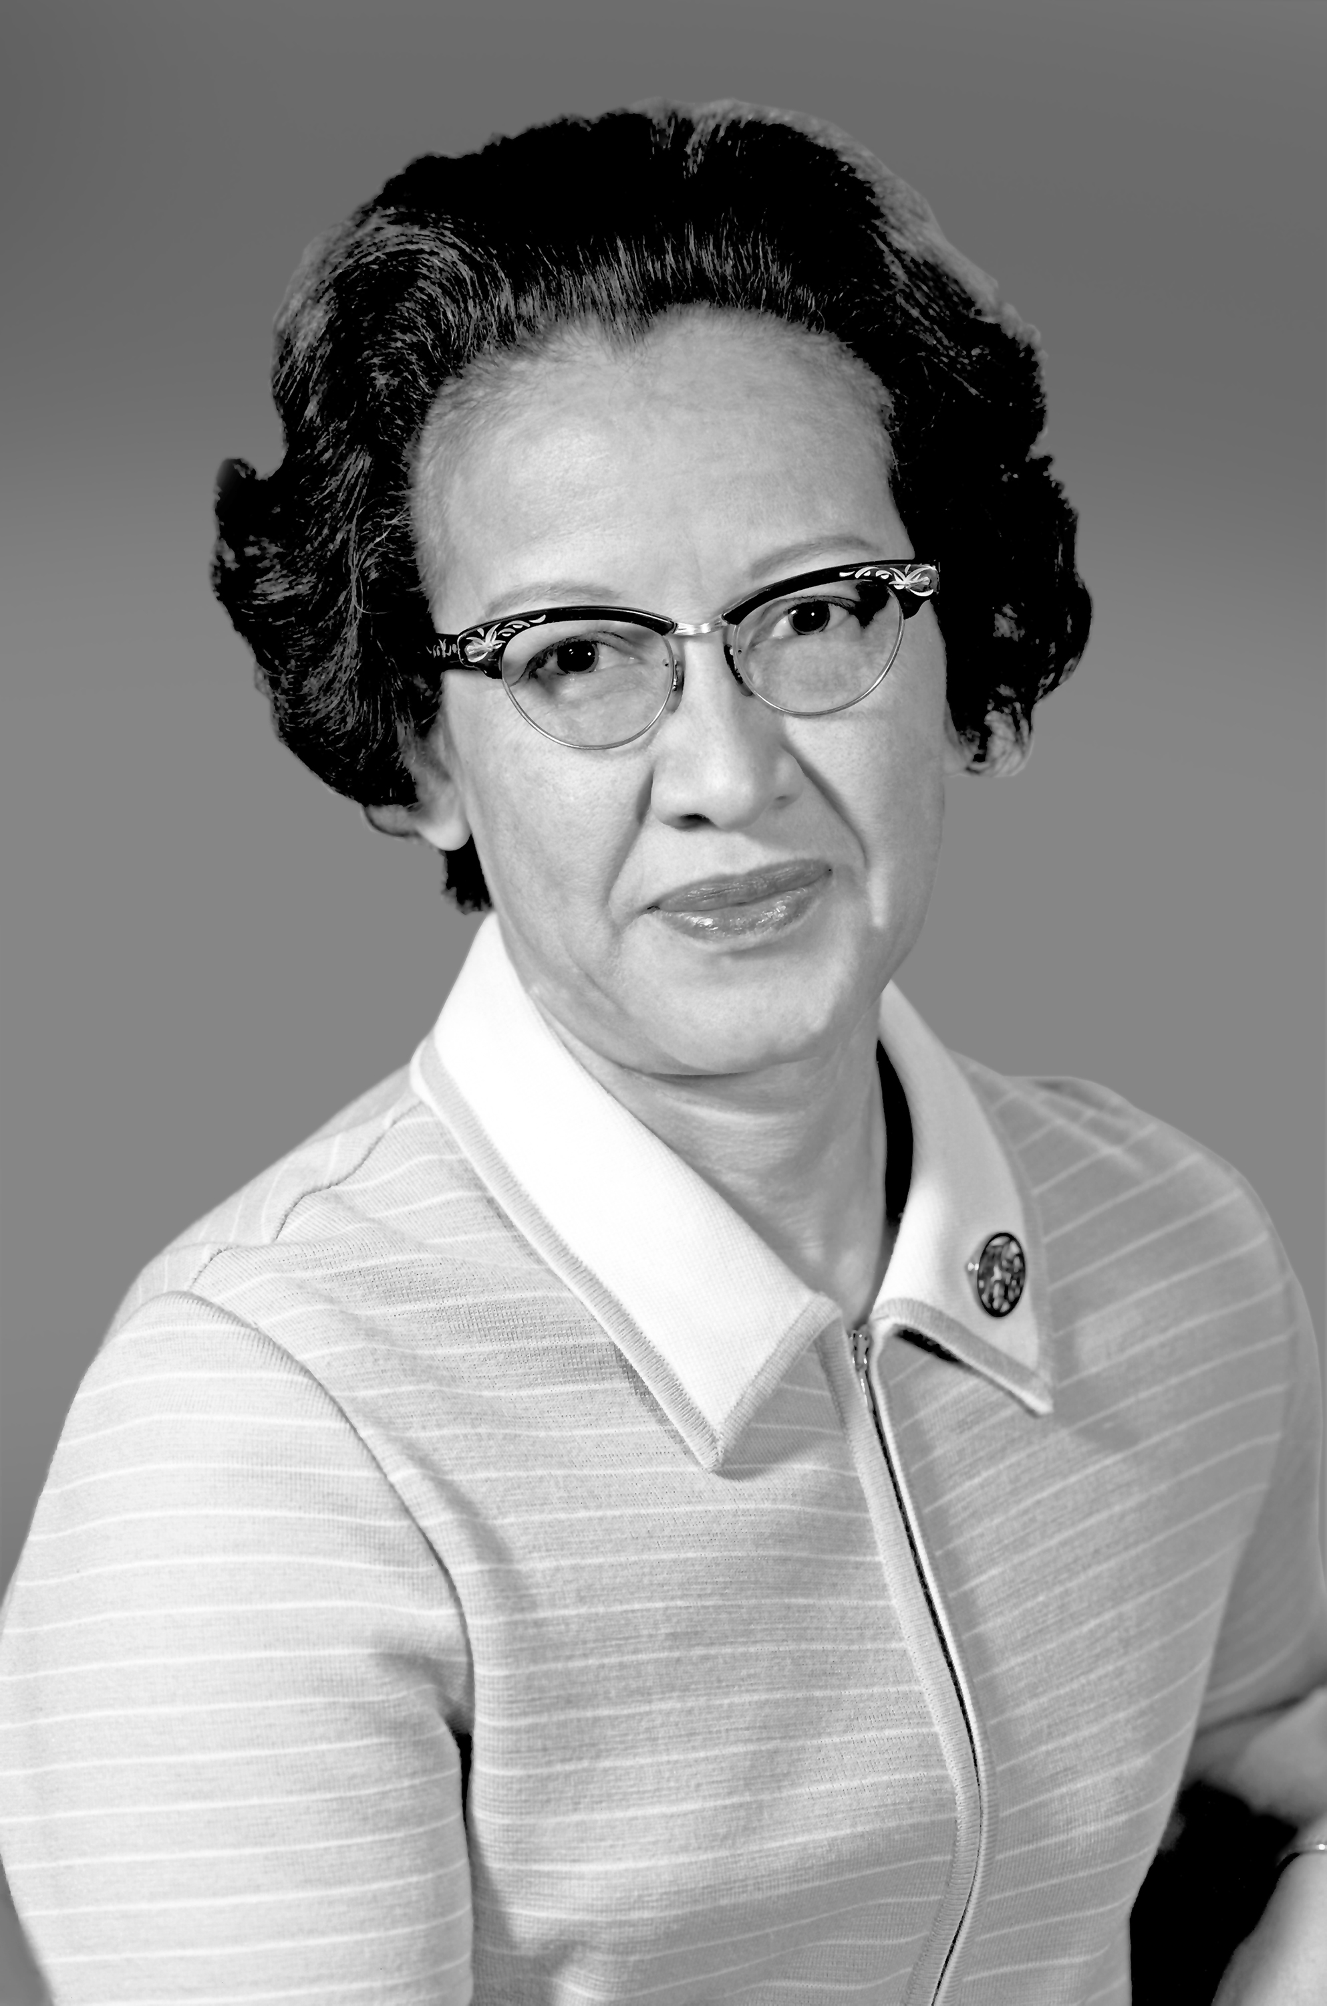 |  | 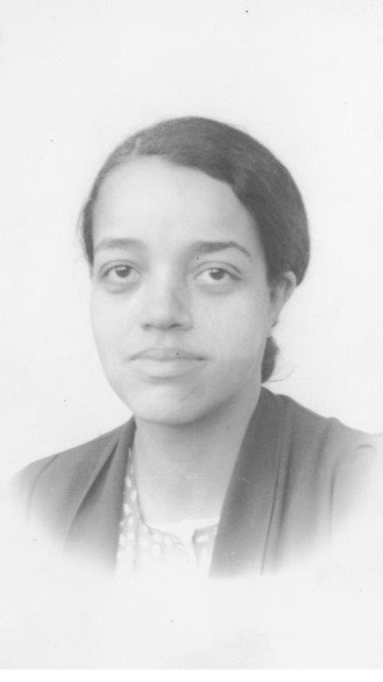 | 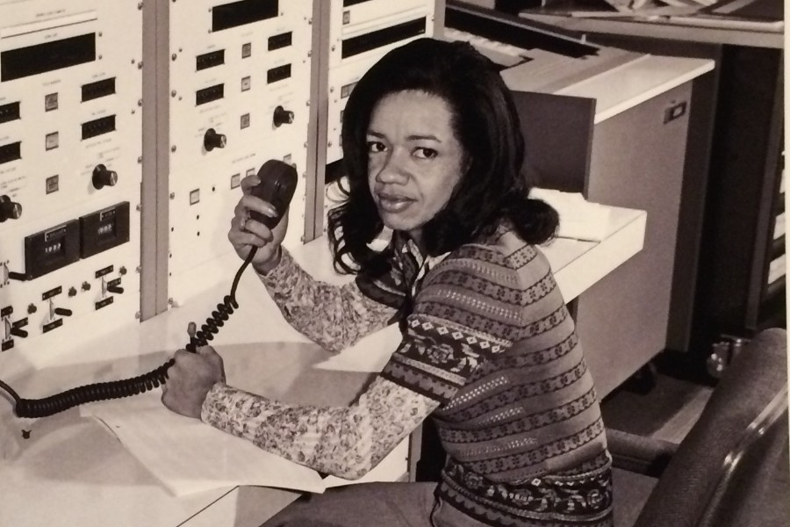
Story book focus |  |  |  | Glossary
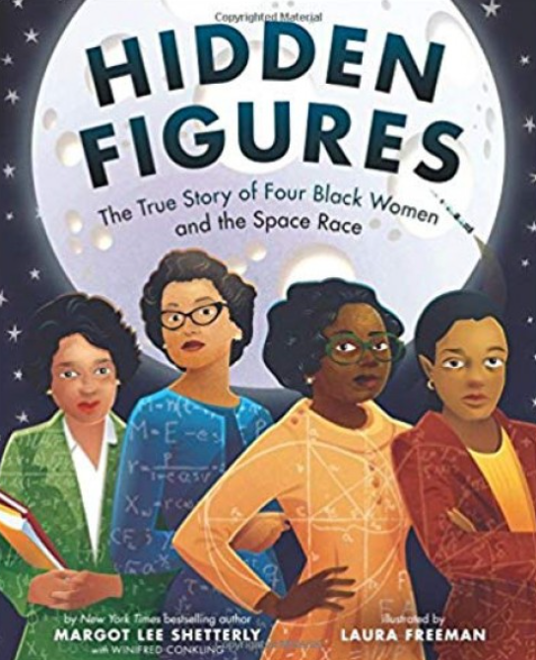 |  |  | - Aeronautics- The science of flying.  - Engineer- A person who has specific training and who designs and builds machines, like airplanes.  - NACA- The National Advisory Committee for Aeronautics, formed in 1915.  - NASA- The National Aeronautics and Space Administration, formed 1958.  - Orbit- The curved path of an object or spacecraft as revolves around a star, moon or planet.  - Satellite- A man-made object placed in orbit around the Earth, its moon or another planet to collect information or help with communication.  - Sonic boom- The sound associated with shock waves created when an object travels through the air faster than the speed of sound.  - Speed of sound- The distance travelled by a sound wave in a fixed period of time.  - Wind tunnel- A tool used in aeronautics research to study the effects of air moving over an object.

