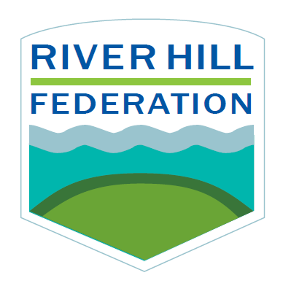
ROTHERHITHE PRIMARY SCHOOL
School Closure Weekly Timetable
Year 4 (Summer 1, week 5)

Subject | Monday | Tuesday | Wednesday | Thursday | Friday
English | LO: I can explore word meaning in a story  Link to lesson: https://www.thenational.academy/year-4/english/story-reading-comprehension-word-meaning-year-4-wk2-1 | LO: I can retrieve facts from a story.  Link to lesson: https://www.thenational.academy/year-4/english/story-reading-comprehension-fact-retrieval-year-4-wk2-2#slide-3 | LO: I can identify the features of a text.  Link to lesson: https://www.thenational.academy/year-4/english/story-identifying-the-features-of-a-text-year-4-wk2-3#slide-3 | LO: I can identify fronted adverbials.  Link to lesson: https://www.thenational.academy/year-4/english/story-spag-focus-fronted-adverbials-year-4-wk2-4#slide-3 | LO: I can continue a story.  Link to lesson: https://www.thenational.academy/year-4/english/story-continue-a-story-year-4-wk2-5#slide-3
Maths | Monday: Equivalent fractions  Watch the video ‘equivalent fractions and simplifying’ on maths with parents. Complete the activities. | Tuesday: Equivalent fractions  Watch the video ‘equivalent fractions and simplifying’ on maths with parents. Complete the activities. | Wednesday: Adding and subtracting fractions  Watch the video ‘Improper Fractions’ on maths with parents. Complete the activities. | Thursday: Adding and subtracting fractions  Watch the video ‘Addition and Subtraction of Mixed and Improper Fractions’ on maths with parents. Complete the activities. | Friday: Converting between improper to mixed number  Watch the video ‘Addition and Subtraction of Mixed and Improper Fractions’ on maths with parents. Complete the activities below.
Exercise | PE with Joe Wicks (You can find his videos on YouTube). | PE with Joe Wicks (You can find his videos on YouTube). | PE with Joe Wicks (You can find his videos on YouTube). | PE with Joe Wicks (You can find his videos on YouTube). | PE with Joe Wicks (You can find his videos on YouTube).
SPAG | Practise  Look, say, cover, write, check | Draw a picture  Draw a picture of each spelling to help you remember its meaning. | Practise  Look, say, cover, write, check | Sentences  Use each spelling in a sentence. | Story writing  Use this time to edit your story and check if you have managed to use any of your spellings in your English story.
Science/ Foundation | History: Henry VIII Lesson One  Link to lesson:  https://www.thenational.academy/year-4/foundation/henry-viii-lesson-1-year-4-wk1-1 | History: Henry VIII Lesson Two  Link to lesson:  https://www.thenational.academy/year-4/foundation/henry-viii-lesson-2-year-4-wk1-4 | Music  Link to lesson:  https://www.thenational.academy/year-4/foundation/pulse-year-4-wk1-5#slide-2 | History: Henry VIII Lesson Three  Link to lesson:  https://www.thenational.academy/year-4/foundation/henrys-viii-lesson-3-year-4-wk2-1#slide-3 | Art: Henry VIII portraits
Wellbeing | https://www.cosmickids.com/ | https://www.cosmickids.com/ | https://www.cosmickids.com/ | https://www.cosmickids.com/ | https://www.cosmickids.com/

