Daily Lessons with Oak National Academy at https://www.thenational.academy/online-classroom/reception#schedule
Additional Activities
English and Literacy | Maths | Educational Online Games | Additional
Family Zone  Lots of fun, family friendly books to read.  https://literacytrust.org.uk/family-zone/  Scholastic  Free books and resources  https://www.scholastic.com/parents/school-success/home-learning-resources.html  Phonics with Ruth Miskin 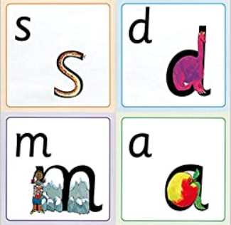  https://www.youtube.com/channel/UCo7fbLgY2oA_cFCIg9GdxtQ  Geraldine the Giraffe  Engaging phonics videos  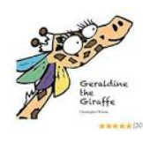  https://www.youtube.com/channel/UC7sW4j8p7k9D_qRRMUsGqyw  Pinkcredible Story Maker 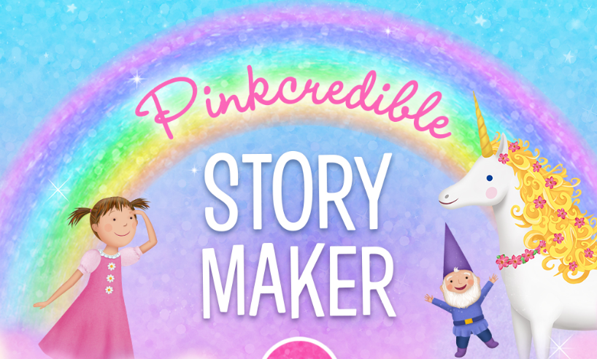  https://pbskids.org/pinkalicious/games/pinkcredible-story-maker  David Walliams Audio Stories  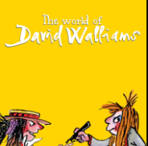https://www.worldofdavidwalliams.com/elevenses/  https://home.oxfordowl.co.uk/ | Bedtime Maths  Non-screen / off-line maths ideas at home  http://bedtimemath.org/fun-math-at-home/  The Maths Factor with Carol Vorderman  https://www.themathsfactor.com/  White Rose: Daily lessons  https://whiterosemaths.com/homelearning/early-years/  Numbots  Find your personalised login information on Tapestry.  https://play.numbots.com/#/intro | Phonics Play  https://new.phonicsplay.co.uk/  Username: march20  Password: home  Busy things  Username: home79  Password: red79  https://www.busythings.co.uk/play/  Espresso  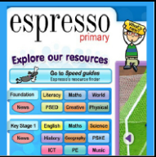  Username: student21443  Password: rps685  https://www.discoveryeducation.co.uk/what-we-offer/discovery-education-espresso/maths-resources  San Diego Zoo Games  https://kids.sandiegozoo.org/games | Disney Dance-a-long!  Watch families dance along to Disney songs and join in! Make your own video to share with friends!  https://www.thisgirlcan.co.uk/activities/disney-workouts/  Change 4 Life  Delicious recipes to cook with your kids!  https://www.nhs.uk/change4life/recipes/tuna-and-bean-jackets  e-bug  A fun way to learn about microbes and anti-biotics!  https://www.e-bug.eu/homepage.html?level=junior  PE with Joe Wicks  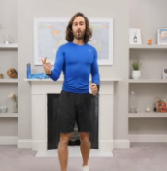  https://www.youtube.com/playlist?list=PLyCLoPd4VxBvQafyve889qVcPxYEjdSTl  Cosmic Kids Yoga  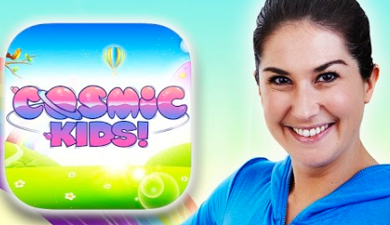  https://www.youtube.com/user/CosmicKidsYoga  Twinkl: Free online and printable resources  Enter code: UKTWINKLHELPS  https://www.twinkl.co.uk/search  Covibook: A child-friendly way to discuss the coronavirus.  https://www.mindheart.co/descargables
BBC Bitesize Daily: Daily Lessons in all subjects
Online or on BBC iplayer
https://www.bbc.co.uk/bitesize/articles/z6vpnrd
