W/C 27.04.2020: Learning Project - Under the Sea
Age Range: KS1
As of this week we would like your child to watch and complete the virtual Maths and English activities. Please find the links for each days lesson in the Maths and English sections below. There are also additional activities that you can do with your child in this document. Please check your emails for this weeks plans.
Weekly Reading Tasks | Weekly Phonics Tasks-
Monday- Encourage your child to learn the rhyme ‘A Sailor went to Sea, Sea, Sea’. Click here for a video of the rhyme and lyrics. Can your child perform this rhyme by heart? | Monday- Go on a sound hunt with your child around the house/garden. They can list all of the items they can find containing the ‘ea’ sound. They may identify objects that contain an alternative way of spelling the ‘ea’ sound such as ee/y/e. The ea family sheet in the Year 1 file may help.
Tuesday- Task your child with building an ‘Under the Sea’ themed reading den. Can they find some sea-themed books to cosy up with and share in there? | Tuesday- Can your child list words that they associate with the sea? Following this, ask your child to identify words that rhyme with these. Watch the clip below together and see if you can add anymore words to your life. https://www.youtube.com/watch?v=kAphgHhlteM
Wednesday- Read ‘The dinosaur who pooped a princess’ and complete the reading comprehension in the year 1 file. | Wednesday- Encourage your child to practise spelling the months of the year and then use them in a sentence.
Thursday- Ask your child to make a sea-themed bookmark. They could take inspiration from ‘Sharing a Shell’ or ‘The Snail and the Whale’. | Thursday- Your child could visit Phonics Play and play Buried Treasure.
Friday- Your child could read a story/poem/nursery rhyme to another family member. This could be to a younger sibling before bedtime or they may wish to Facetime an elderley relative (with adult supervision of course). | Friday- Ask your child to write the alphabet using capital letters. Challenge your child to write the lowercase letters too.
Topic- Geography, Science and RE  Encourage your child to watch the Geography lessons and complete the tasks. See Monday and Wednesday writing tasks with the attached links. 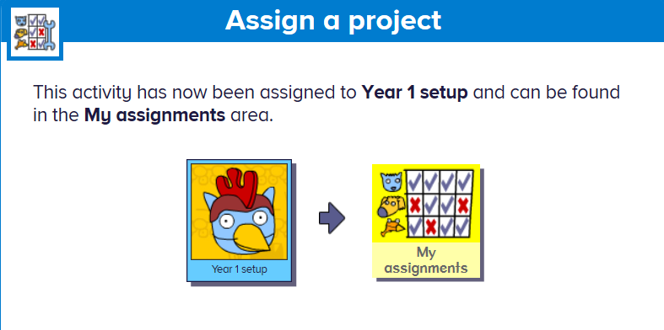  Using the Busy Things login, go onto the my assignments area to find this weeks RE learning on Ramadan.  http://www.busythings.co.uk/  username: home79  password: red79 | Please continue to use ensure your child is doing phonics activities daily. Daily phonics – will help your child to practice their sounds and blend words. We have set some specific tasks on Busy Things using the login below:  http://www.busythings.co.uk/  username: home79 password: red79  Please refer to your emails.  Interactive games can also be found on links below:  ● Phonics play https://www.phonicsplay.co.uk/  ● Top Marks https://www.topmarks.co.uk/Search.aspx?AgeGroup=2  ● Spell the days of the week https://www.bbc.co.uk/teach/supermovers/ks1-english-days-of-the-week/zd8njhv  ● Spell common exception words- see spelling list
Weekly English Tasks  This weeks daily virtual lessons can be found at https://www.thenational.academy/online-classroom/year-1#schedule under week 3 4th May | Weekly Maths Tasks- Time  This weeks daily virtual lessons can be found at https://www.thenational.academy/online-classroom/year-1#schedule Under week 3 4th May. Please also continue to use the White Rose lessons to recap on learning.
Monday- English week 3- Hear a story link:https://www.thenational.academy/online-classroom/year-1#schedule  Geography- This term we are learning about the world. Watch the lesson below all about continents:  https://www.thenational.academy/year-1/foundation/what-is-a-continent-year-1-wk1-1 | Monday- Maths week 3:- Recognise read and write numbers to 100 link: https://www.thenational.academy/online-classroom/year-1#schedule  Additional:  Write the days of the week on paper and cut them up into cards. Take turns turning over the cards. If, when you turn the card, you have a day that is before or after the day shown you can say snap.
Tuesday- English week 3-To commit a story to memory link: https://www.thenational.academy/online-classroom/year-1#schedule  Additional:  Task your child with planning the perfect beach trip. Ask them to draw and label all of the things that they would pack including a picnic. Who would they take? What games would they play? How much time would they spend in the sea? | Tuesday- Maths week 3:- Explore components of numbers within 100 link: https://www.thenational.academy/online-classroom/year-1#schedule  Additional:  With your child, list different activities/chores they have to do throughout the day. Can they order them after making the list? Can your child sort them into the times of day each thing happens in (e.g. morning, afternoon, night etc)?
Wednesday- English week 3-To identify features of a characters appearance link: https://www.thenational.academy/online-classroom/year-1#schedule  Geography- This lesson is all about Europe. I wonder what you’ll learn today?  https://www.thenational.academy/year-1/foundation/what-is-europe-like-year-1-wk1-4 | Wednesday- Maths week 3:- Explore components of numbers within 100 link: https://www.thenational.academy/online-classroom/year-1#schedule  Additional:  Write the months of the year on separate pieces of paper and mix them up. Can your child order them correctly?
Thursday- English week 3- To identify features of a characters personality link: https://www.thenational.academy/online-classroom/year-1#schedule  Additional:  Visit a desert island here. Ask your child to write a message in a bottle. What can they see, hear, feel, taste and smell? Why not roll the message up and pop it in a plastic bottle for the reading den? | Thursday- Maths week 3:- Apply knowledge of number bonds link: https://www.thenational.academy/online-classroom/year-1#schedule  Additional:  Using a clock in your house practise telling the time with your child to the nearest hour, half hour, 15 minute intervals and 5 minutes intervals.
Friday- English week 3- To write a character description link: https://www.thenational.academy/online-classroom/year-1#schedule  Additional:  Speak to your child about all of the things that make them happy or all of the things that they’re grateful for. Ask them to record these in a list. | Friday- Maths week 3:- Find one more or one fewer, and 10 more and 10 fewer link: https://www.thenational.academy/online-classroom/year-1#schedule  Additional:  Ask your child to survey the family about their favourite sea creature (choose from 5). Represent the results using a tally chart or a pictogram. Which sea creature was the most popular? Which was the least popular?
Please also use:
White Rose Maths online maths lessons. Watch a lesson video and complete the worksheet- this week’s learning will be under Summer week 2 (can be downloaded and completed digitally).
Times Table Rockstars and Numbots. Your child can access this programme with their school login.

Learning Project – More additional activities
The project this week aims to provide opportunities for your child to learn more about life in and around the sea. Learning may focus on the strange and wonderful creatures and plants that occupy our oceans, their habitats and how human beings affect this environment.

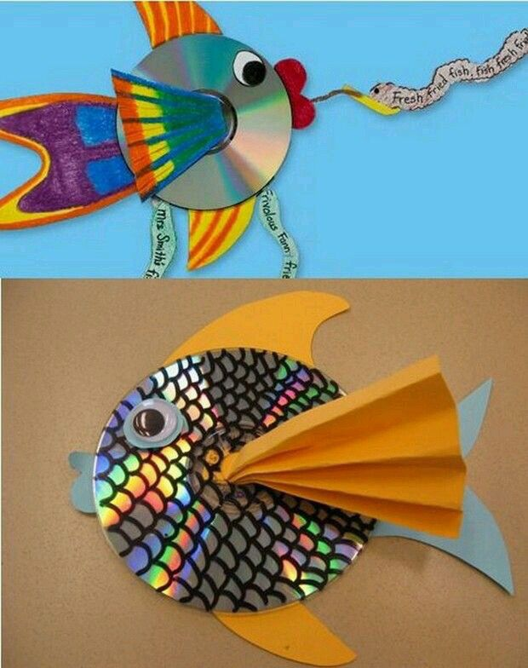
- Guess Who?- Ask your child to write fact cards about animals from under the sea. They can use books or websites to find out about the appearance, habitat and diet of each creature. After this, play a game of ‘Guess Who?’ using the cards and yes/no questions.

- Junk Modelling- Using junk or recycling materials from around the home, ask your child to design and make a Sea Turtle. Your child may wish to make another sea creature after this. Share your creations on Twitter using #TheLearningProjects.

- Put Your Goggles On- Your child can visit this website and watch a live stream of a tropical reef. Whilst watching, ask them to sketch all of the animals that they can see. Remind them to look at the shapes and patterns on each creature and to include these in their sketches.

- How do Humans Affect the Sea?- Is your child aware of all of the ways that humans affect the sea and the living things within it? Talk about and investigate the impact that human beings have on the sea. Think about fishing, transport and pollution. Create a poster or information report.

- The Oceans of the World- Using an atlas or the web ask your child to identify the world’s oceans. Year 1 children may need some support with this. Can they find out what animals live in each ocean? This game allows your child to practise naming and locating the oceans.
STEM Learning Opportunities #sciencefromhome
Unplugged Coding
- Watch this video.
- Create a simple under the sea obstacle course or draw an obstacle course on a piece of paper. Write simple code to guide the submarine around the obstacles found under the sea. E.g. Rocks, shipwrecks, sleeping octopus. E.g. →→↓→→↑→ etc.
#Additional learning resources parents may wish to engage with
- Visit this BBC website for more sea themed music and learning ideas.
- There are some lovely games and ideas from the Royal National Lifeboat Institution here.
- IXL- Click here for Year 1 or here for Year 2 . There are interactive games to play and guides for parents.
- Mastery Mathematics Learning Packs Learning packs with a range of different activities and lessons. There are notes on how to do these activities with your children.
- Y1 Talk for Writing Home-school Booklets are an excellent resource to support your child’s speaking and listening, reading and writing skills.
The Learning Projects are based on the National Curriculum expectations for the key stage which your child is in. It may be that your child finds the tasks set within the Learning Project for their year group too simple. If this is the case, then we suggest that your child accesses the Learning Projects which are set for the key stage above. Equally, if the projects are too challenging, then we advise that your child accesses the projects for the key stage below.
If your child requires more of a challenge, or you believe that there are some gaps in their learning then Century Tech is a fantastic resource that is currently free for home learning. The app is designed to address gaps and misconceptions, provide challenge and enables children to retain new knowledge. It uses artificial intelligence to tailor the learning to your child’s needs. Sign up here.
#TheLearningProjects
in collaboration with
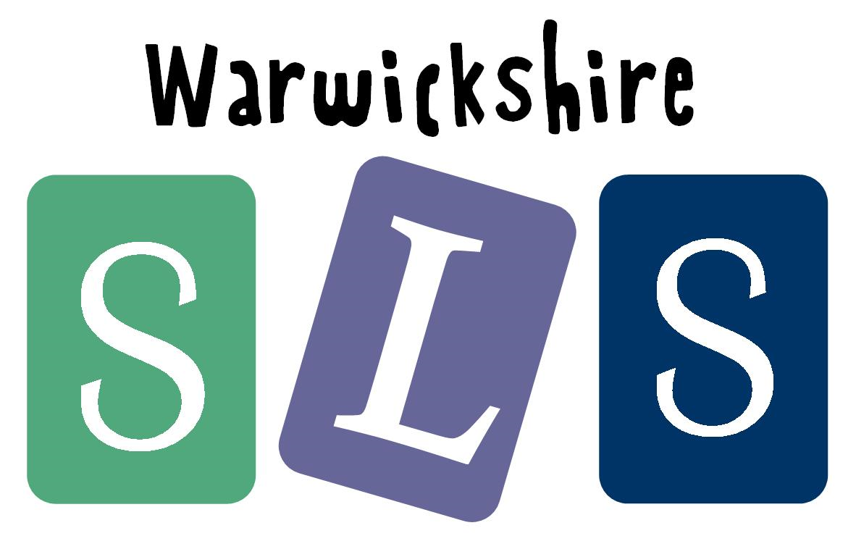
www.robinhoodMAT.co.uk

