Monday
LO: I can calculate the area of rectangles by counting squares
Watch the video about calculating the area of rectangles on Maths with Parents and then complete these questions,
- What is area of these rectangles?
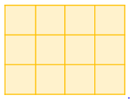
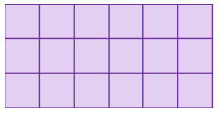

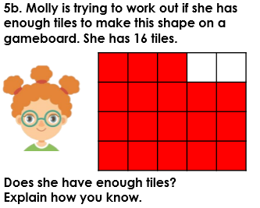

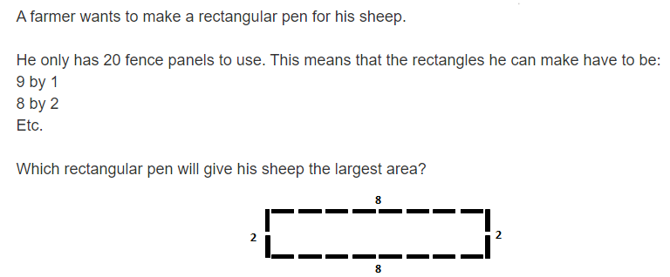

Tuesday
LO: I can convert measures
Watch the video on Maths with Parents about converting measures and then answer these questions.
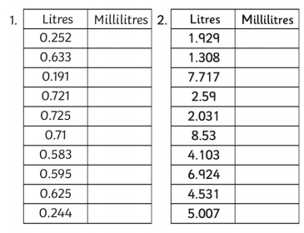
- A chef has one measuring cup with only L on it and another measuring cup with only ml on it. Help her get her measurements sorted by completing these tables.

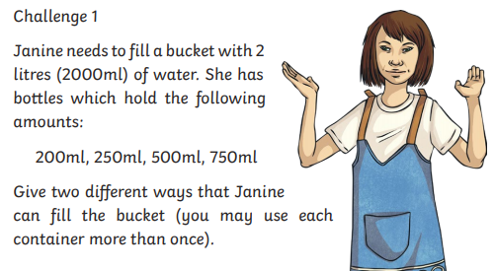

Wednesday
LO: I can convert measures
Watch the video on Maths with Parents about converting measures (video from yesterday), then answer these questions.
- Practise reading the scales and recording the weight. Can you convert the g to kg?
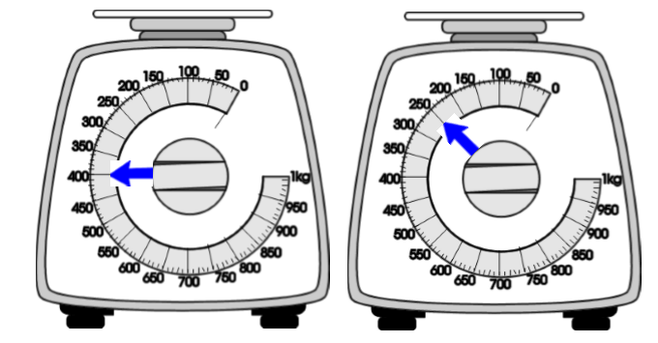

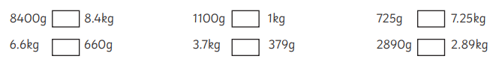
- Use <, = or > to complete the following sentences:

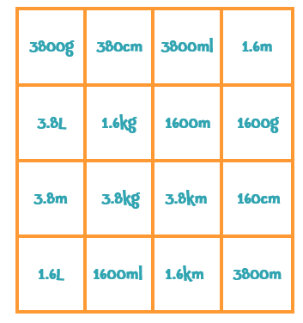
- Can you find the matching measurements?

Thursday
LO: I can calculate the perimeter of rectangles
Watch the Math with Parents video about the perimeter of rectangles and then answer the following questions.
- What is the perimeter of this shape?
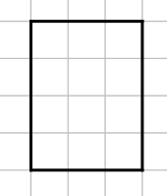

- Which shape has the longer perimeter? 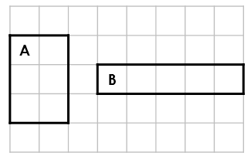

Challenge:
- Cut out 12 equal-sized squares of paper. Put them into one long rectangle. What is the perimeter of this rectangle?
- Rearrange them to make different rectangles – do they all have the same perimeter?
- How many different perimeters can you make by rearranging these squares?

Friday
LO: I can calculate the perimeter of a rectangle
Watch the video on Maths with Parents to remind you about perimeter (yesterday’s video).
- Which shape is the odd one out? Explain your reasoning. 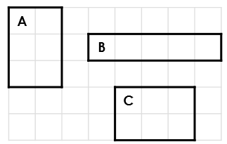
- Stephen thinks the perimeter of this rectangle is 14cm. What mistake has he made?

- Can you draw a rectangle that has an even perimeter?
Can you draw a rectangle that has an odd perimeter?
Explain why you can’t do one of them.

