Each day gets progressively harder. Do not skip a day as you will need the learning from the previous day to understand the day after – do them in the correct order. There are three challenges per day. Each one gets a little harder, so start with the first and work your way down. Don’t panic if you can’t do them all. Watch the video again and as an adult for help.

Equivalent fraction wall to help you this week:
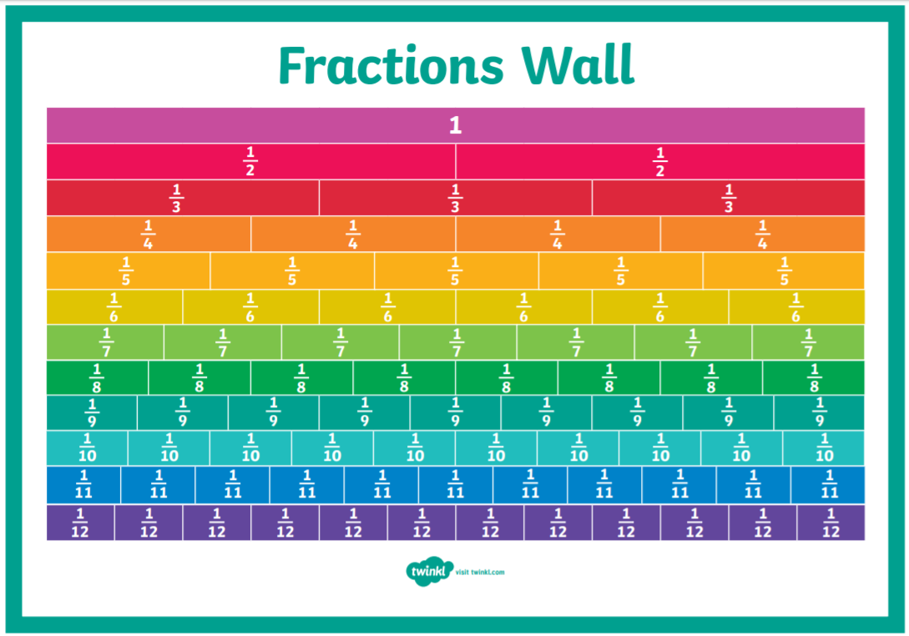

Monday: Equivalent fractions
Watch the video ‘equivalent fractions and simplifying’ on maths with parents. Complete the activities below. Remember you can watch the videos lots of times and use your fraction wall to help you (or challenge yourself to do it without!)
Practise
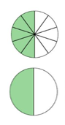
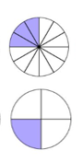
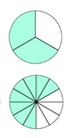
Write the equivalent fractions shown in each pair of diagrams.
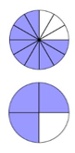

Apply
Write an equivalent fraction in the boxes. Use the shapes to help you.
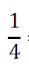
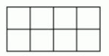
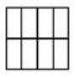
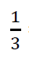
= = =

Challenge
Fill in the missing boxes. What else could you use to help you? (psst… The fraction wall and multiplication!)
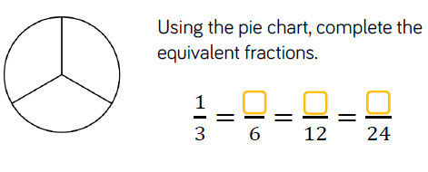

Tuesday: Equivalent fractions
Watch the video ‘equivalent fractions and simplifying’ on maths with parents. Complete the activities below. Remember you can watch the videos lots of times and use your fraction wall to help you (or challenge yourself to do it without!)
Practise
Use the diagram to complete the fractions.
$\frac{1}{4}$ = $\frac{}{12}$
1 | 2 | 3 | 4 | 5 | 6 | 7 | 8 | 9 | 10 | 11 | 12
1 |  |  | 2 |  |  | 3 |  |  | 4

$\frac{1}{}$ = $\frac{3}{6}$
1 | 2 | 3 | 4 | 5 | 6
1 |  |  | 2

Apply
$\frac{5}{8}$ = $\frac{}{16}$

Reasoning
Spot the error and correct. You may want to draw a fraction wall or use multiplication to help you.
$\frac{8}{12}$ = $\frac{14}{24}$

Challenge
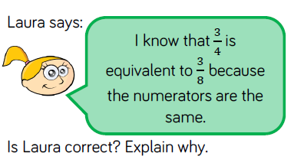
Wednesday: Adding and subtracting fractions
Watch the video ‘Improper Fractions’ on maths with parents. Complete the activities below. Remember you can watch the videos lots of times! Psst! Remember the numerator always stays THE SAME!

Practise
Use the models to add and subtract the fractions.
$\frac{4}{8}$ + $\frac{3}{8}$ = $\frac{}{8}$

$\frac{5}{6}$ $\frac{2}{6}$ + $\frac{3}{6}$ = $\frac{}{6}$

Apply
If you need, use the bar model to solve these problems.
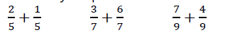

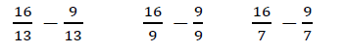

Challenge
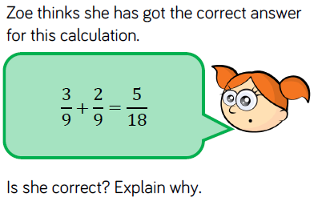

Thursday: Adding and subtracting fractions
Watch the video ‘Addition and Subtraction of Mixed and Improper Fractions’ on maths with parents. Complete the activities below. Remember you can watch the videos lots of times! If you can, challenge yourself to convert your answer from an improper fraction to a mixed number fraction like the children did in the video!
Psst! Remember the numerator always stays THE SAME!
Practise
Shade the models to help you complete the calculations. Can you write your answer as a mixed number fraction too?
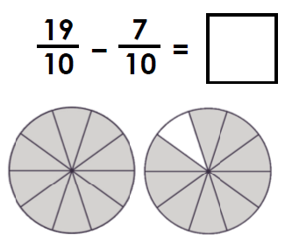
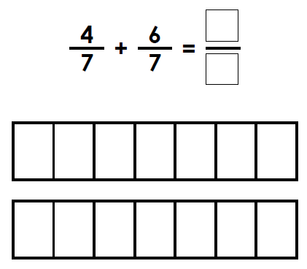

Apply
Use drawings to help you complete these calculations in your book.
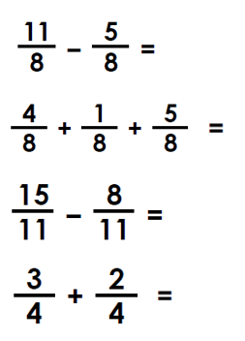
Reasoning
Jake and Steph are finding missing numbers in a calculation. Who is correct? Explain how you know.
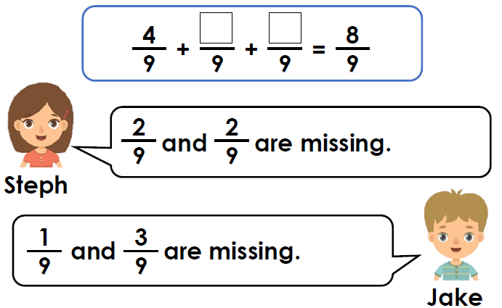
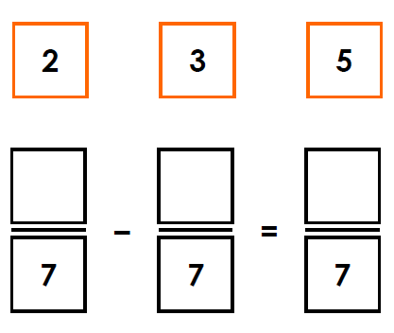
Challenge: Use the digit cards to complete the calculation below.

Friday: Converting between improper to mixed number
Watch the video ‘Addition and Subtraction of Mixed and Improper Fractions’ on maths with parents. Complete the activities below. Remember you can watch the videos lots of times!
Practise: Match the improper and mixed number fractions to their pictorial representation.
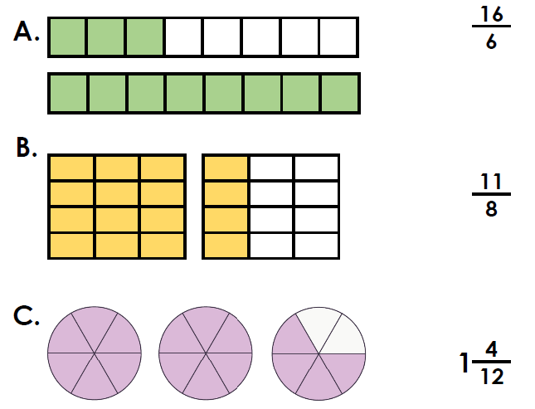
Apply
True or false. The following image represents 1 $\frac{1}{4}$.
Explain your answer.
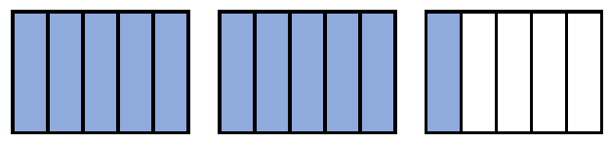
Reasoning
Kara and George are discussing this image. Who is correct. Explain your answer.
