Week 8: Reading and Writing
Hi Year 4! After trialling Oak Academy, we got lots of good feedback from their resources, so will be using the Oak Academy for every reading lesson this week. This week we are focusing on fiction, with extracts from a story I love: Fantastic Beats by JK Rowling! Each day, follow the link to the lesson (make sure to have a pen and pencil ready!) and listen carefully to the video. There are independent tasks for you to do too. To make it easier, I have put the tasks in this workbook too, but you can also view these activities by clicking ‘Next Activity’ when you are watching the videos. After you have finished, the teacher will then go through the answers with you so you can mark your own work! If you really enjoy the little extract from the story that we will be looking at this week, why don’t you read the whole book yourself!
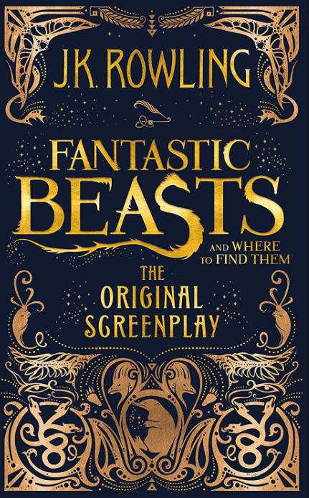
Monday
LO: I can explore word meaning in a story
Link to lesson: https://www.thenational.academy/year-4/english/story-reading-comprehension-word-meaning-year-4-wk2-1
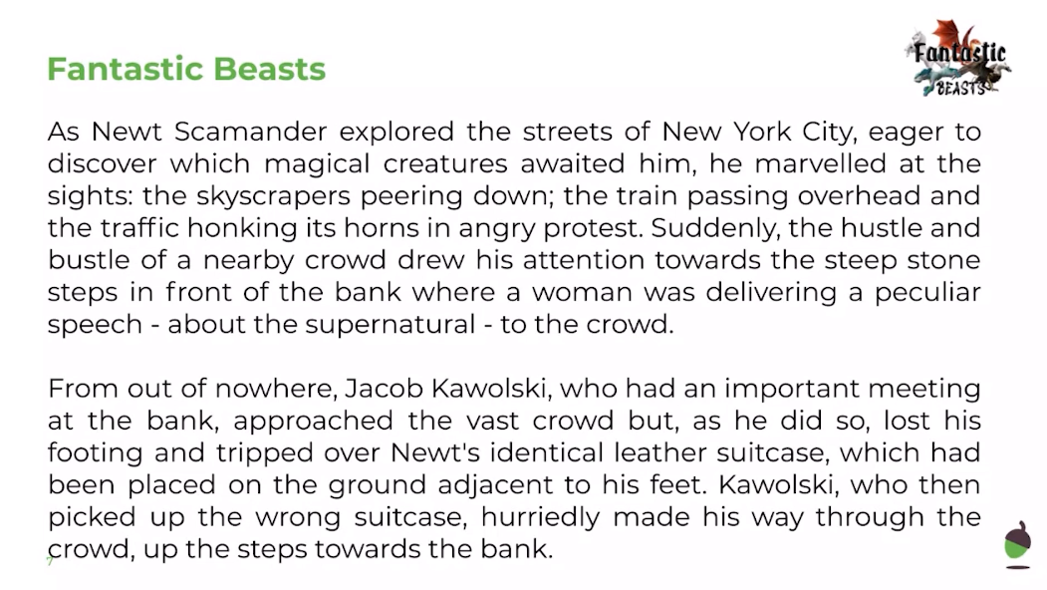
Independent activities

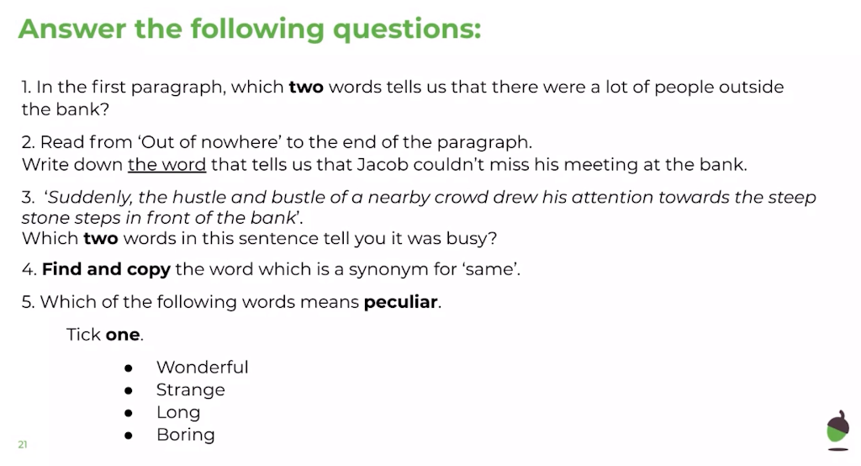

Tuesday
LO: I can retrieve facts from a story.
Link to lesson: https://www.thenational.academy/year-4/english/story-reading-comprehension-fact-retrieval-year-4-wk2-2#slide-3
Independent activities
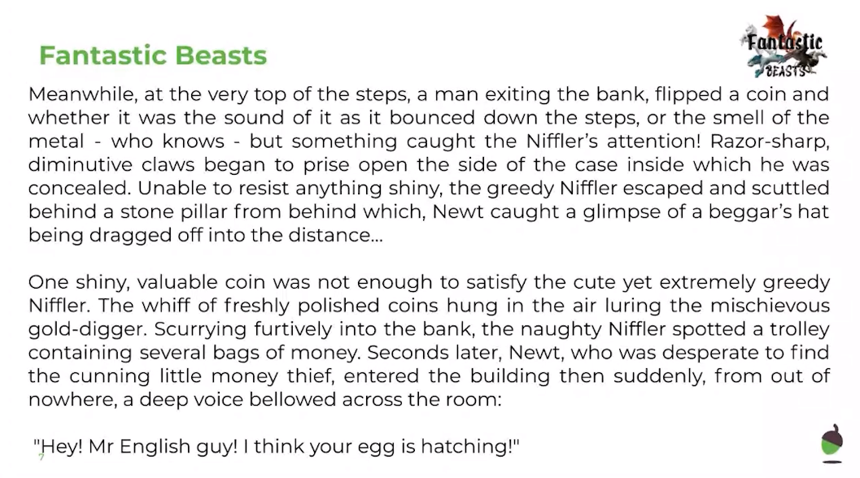

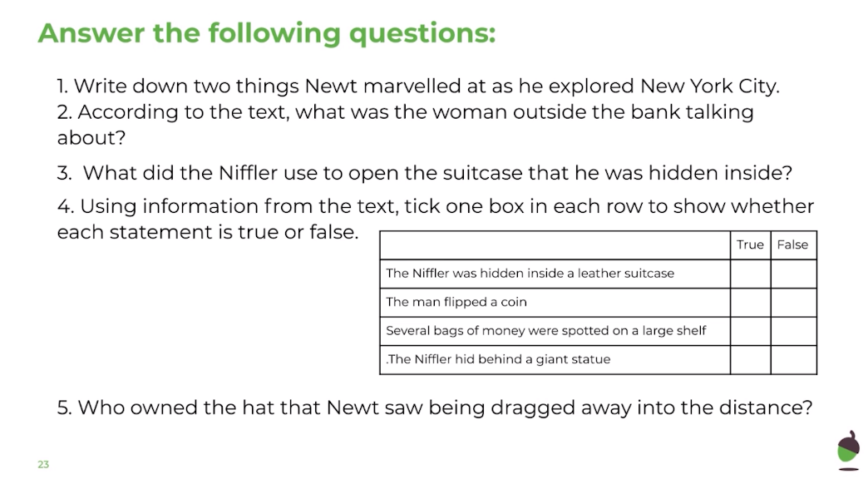

Wednesday
LO: I can identify the features of a text.
Link to lesson: https://www.thenational.academy/year-4/english/story-identifying-the-features-of-a-text-year-4-wk2-3#slide-3
Independent activities
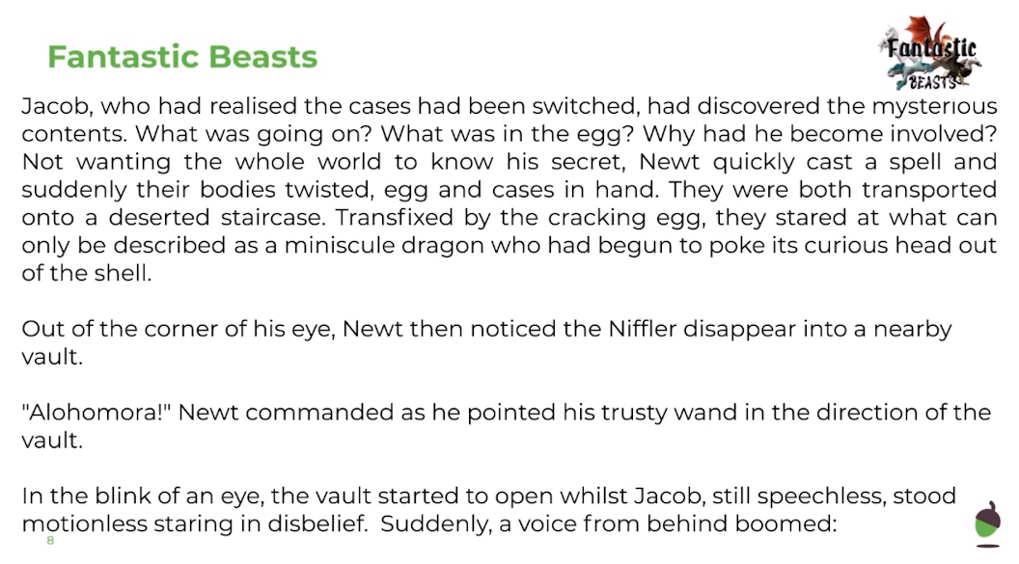

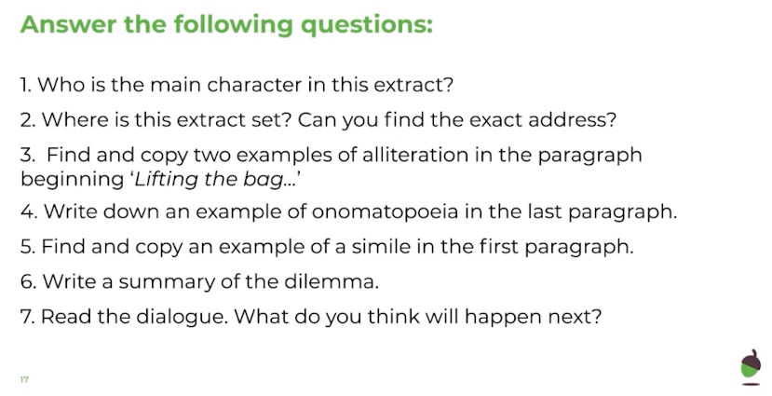

Thursday
LO: I can identify fronted adverbials.
Link to lesson: https://www.thenational.academy/year-4/english/story-spag-focus-fronted-adverbials-year-4-wk2-4#slide-3
Independent activities
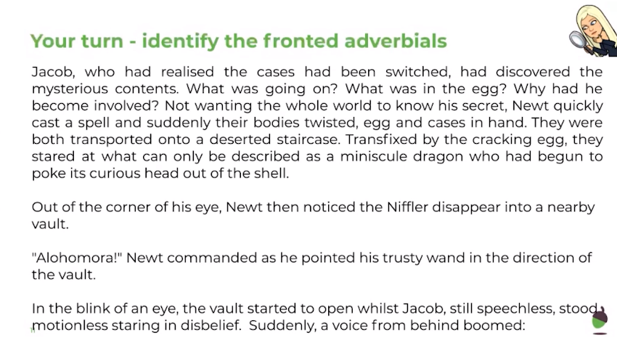
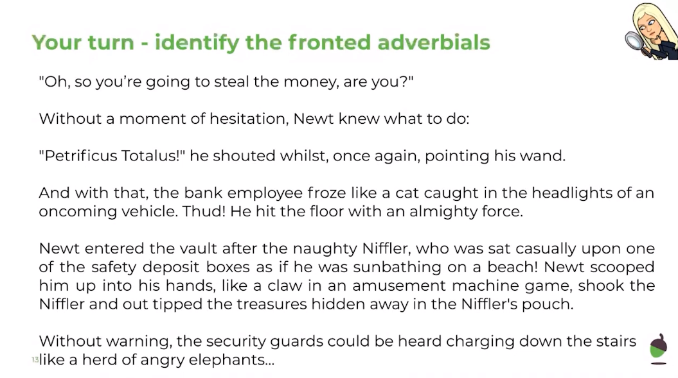
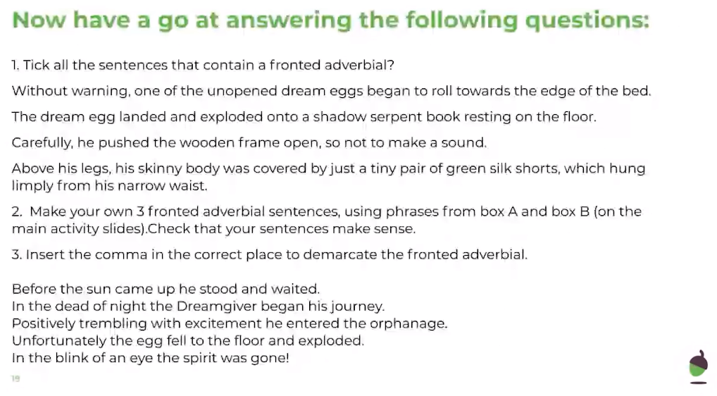

Friday
LO: I can continue a story.
Link to lesson: https://www.thenational.academy/year-4/english/story-continue-a-story-year-4-wk2-5#slide-3
Independent activity
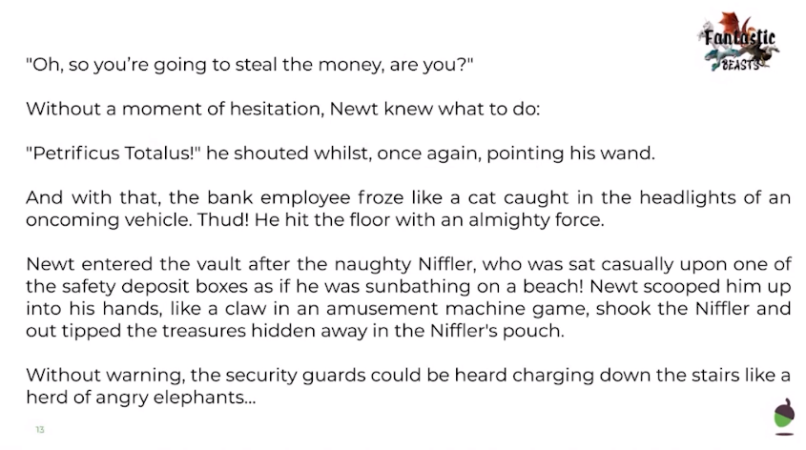
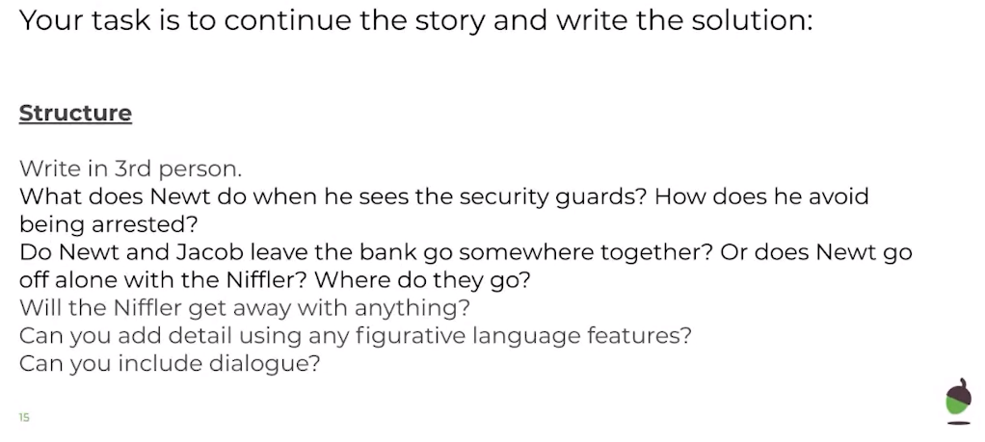

Tools to help you:
