Henry VIII: Lesson 2
Henry’s Great Matter
In order to marry Anne, Henry needed to divorce Catherine, and royal divorces had to be approved by the Pope, who was the head of the Christian Church in Europe. Unfortunately for Henry, the Pope at the time was Pope Clement VII, who was being held prisoner by Catherine’s nephew, the Holy Roman Emperor Charles V.

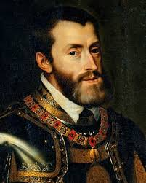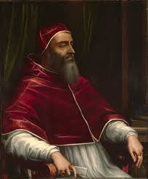

Pope Clement was in no position to offend Catherine by granting Henry an immediate divorce, so he sent Cardinal Campeggio to England in 1529 to negotiate with Henry’s Lord Chancellor, Thomas Wolsey.
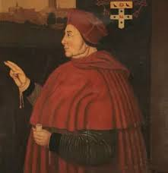

Comprehension Questions:
- Who did Henry fall in love with whilst he was still married to Catherine?
- Whose approval did Henry need in order to divorce Catherine and marry Anne?
- Why couldn’t Pope Clement VII grant Henry an immediate divorce?
Vocabulary Activities:
- Which of these words most closely matches the meaning of the adjective ‘vivacious’?
  - Dull
  - Lively
  - Asleep
- Which of these words or phrases most closely matches the meaning of the adjective ‘valid’?
  - Reasonable or legally binding
  - Ridiculous
  - Noise
- Which of these words of phrases most closely matches the meaning of the adjective ‘smitten’?
  - Angry
  - Bored
  - In love
Challenge:
Choose the word that would go in the gap and write out the full sentences.
Divorce dynasty smitten headstrong reform
- The debate about _________ of the House of Lords is centuries old.
- Her mother always told her she was extremely ___________ because she never listened, and always did exactly as she pleased.
- Julius Caesar was _______ with Cleopatra from the moment he first laid eyes on her.
- The Julio-Claudian ______________ ruled ancient Rome for over a hundred years.
- Prince Charles and Princess Diana had a very acrimonious _____________.

