Monday
LO: I can retrieve facts from a text
At the end of this topic we will be writing a news report, but first we need to investigate how to become a successful news reporter.
- What do news reports look like?
- What are the key features of a news report?
- Can I ‘magpie’ any successful elements to inform my own writing?

Let’s meet the characters in our news report based on Charlie and the Chocolate Factory:
- Willy Wonka- owner of the elusive chocolate factory
- Veruca Salt- lucky golden ticket winner
- Charlie Bucket- lucky golden ticket winner
- Augustus Gloop- lucky golden ticket winner
- Mrs. Gloop- mother of Augustus Gloop
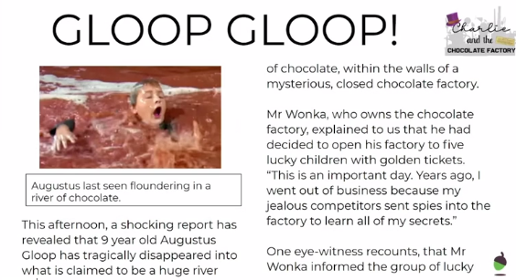
Our Good Example Text:

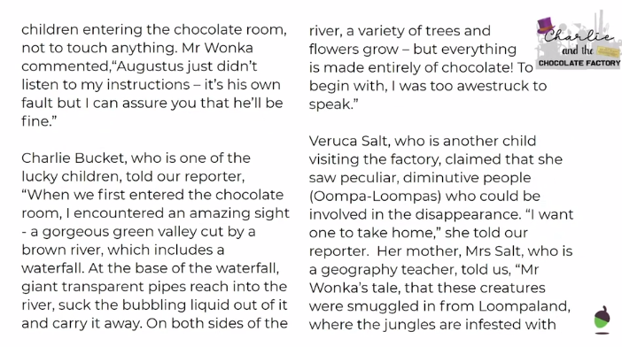
page 2:

Page 3: 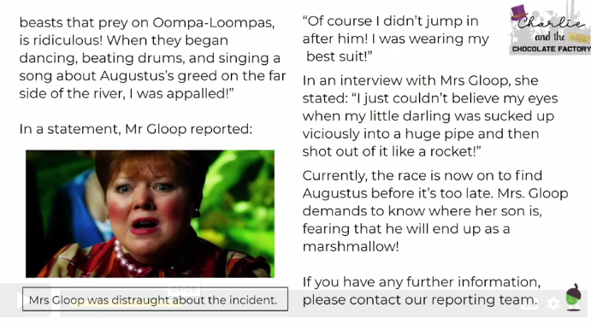

Word of the Day: Variety (noun) -A number of different kinds or examples of the same thing.
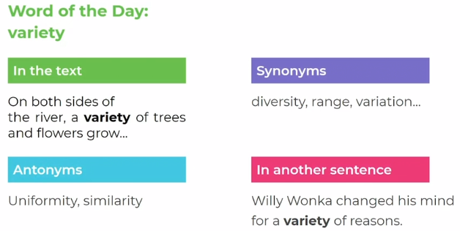

Today we are going to focus on Fact Retrieval. Here is an example question:
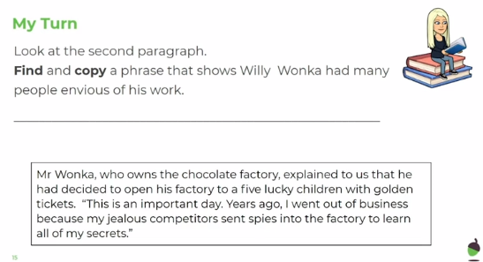
What are my key words? Find and copy. I also need to think about what the word ‘envious’ means. Answer: Jealous competitors sent spies into the factory to learn all of my secrets.
I haven’t just copied down one word, because the question tells me to find and copy a phrase.
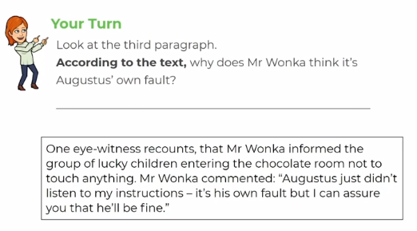
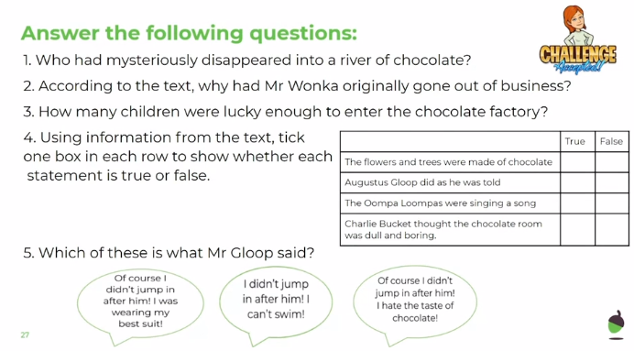

Answers:
- Augustus Gloop
- Because his jealous competitors sent spies into the factory to learn all of his secrets.
- Five
- True, False, True, False
- Of course I didn’t jump in after him! I was wearing my best suit!
Tuesday
LO: I can make inferences
Start today by rereading the Good Example text from yesterday’s lesson to refresh your memory.
Word of the Day: Encounter (verb) -To meet someone or something
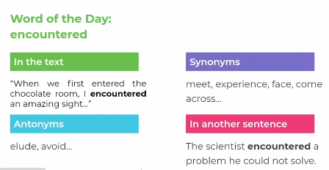

Today we are going to be making inferences. This means:
- use what you have read to come to a conclusion
- form an opinion by reading between the lines
- provide evidence from the text to back up your points

Example question:
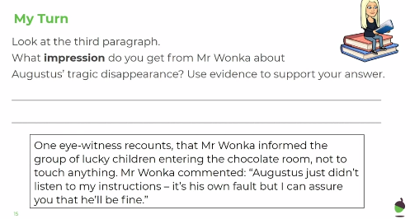
An impression is an idea, feeling or opinion, so I need to think about the idea, feeling or opinion I get from reading the third paragraph. What do I hear in what Mr. Wonka is saying? If someone doesn’t listen, you may feel frustrated.
My answer: I get the impression Mr. Wonka is frustrated as he says, “Augustus just didn’t listen to my instructions.” He is also not worried because he says, “I can assure you he’ll be fine.”
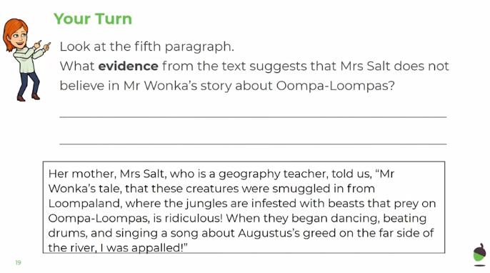
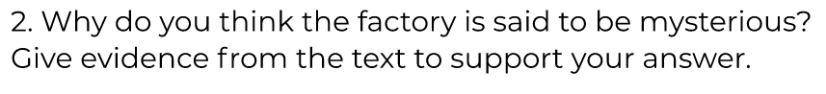
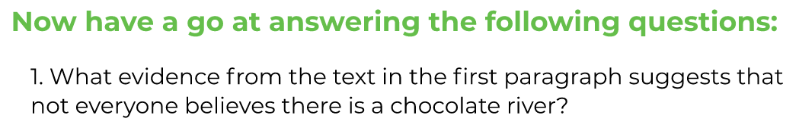
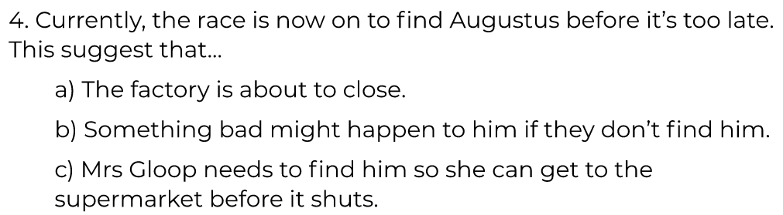
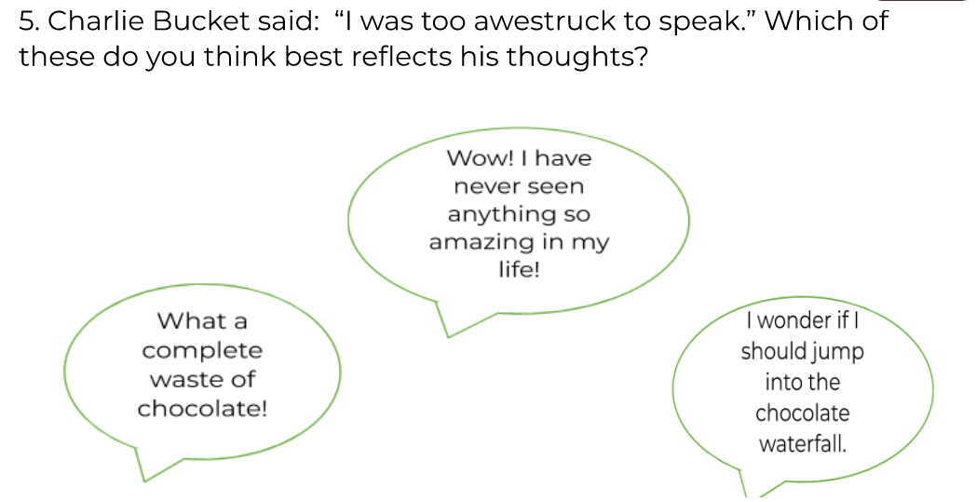
Answers:
- Because it says in the text that Gloop had disappeared mysteriously into what is claimed to be huge river of chocolate.
- Because there are peculiar creatures called Oompa Loompas there and everything is made of chocolate.
- Because she refers to him as ‘little darling’.
- B) Something bad might happen to him if they don’t find him.
- Wow! I have never seen anything so amazing in my life!

Wednesday
LO: I can identify the features of a news report
Word of the Day: Transparent (adjective) -Allowing you to see through it
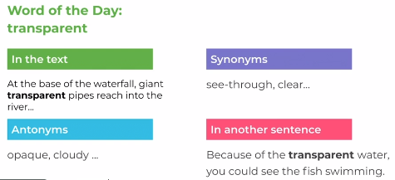

What are the key features of a news report? Which features can we identify?
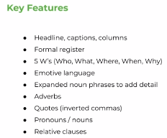
Have look through the Good Example text about Charlie and the Chocolate Factory and see which features you can spot.
Next, read this news report ‘Grandma Grows Giant’ (below) and answer the corresponding questions.
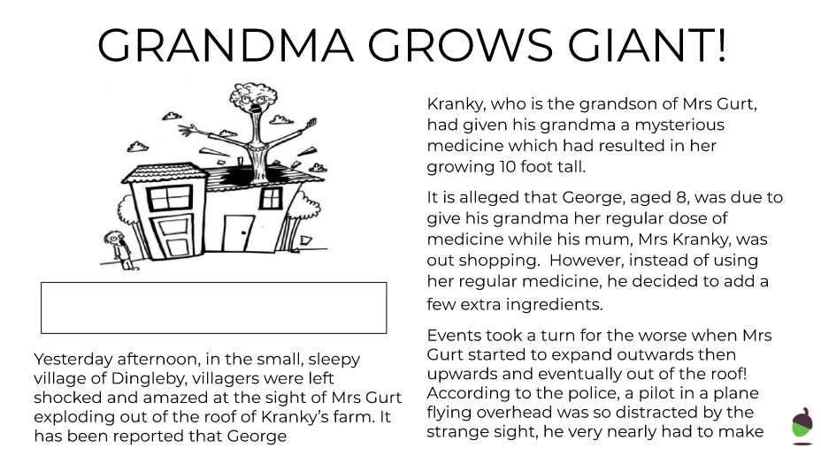
Page 2:
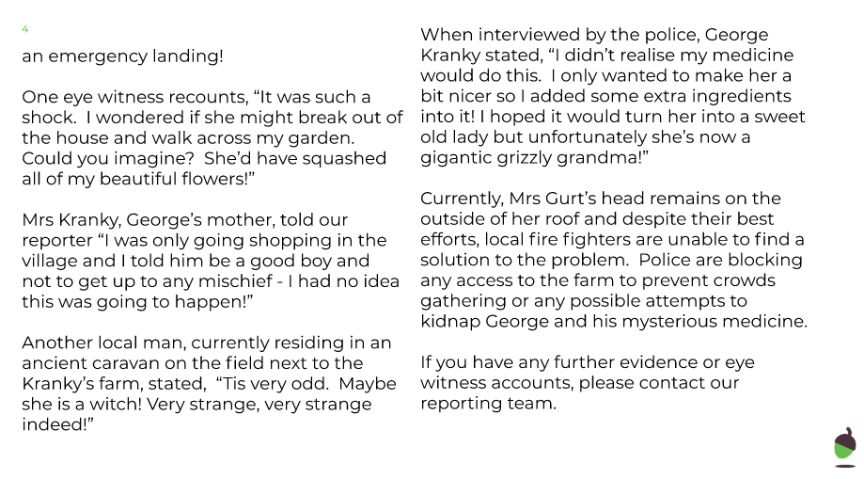
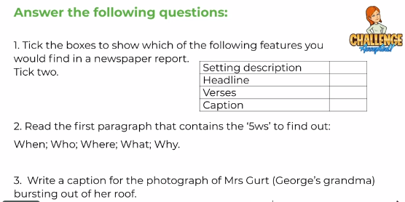
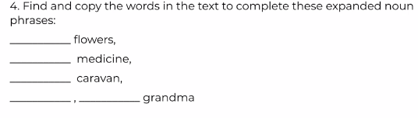
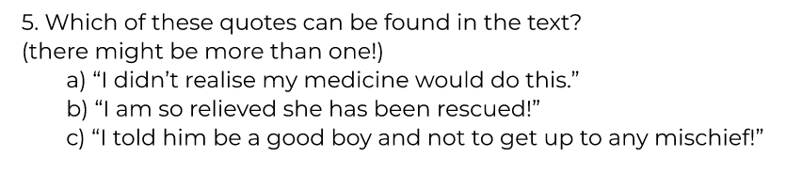
Answers:
- Features: Headline, Caption
- ‘5 Ws’
  - When: Yesterday afternoon
  - Who: Mrs. Gurt
  - Where: Kranky’s farm in Dingleby
  - What: Mrs. Gurt exploded out of the roof of Kranky’s farm
  - Why: George had given her some mysterious medicine
- Possible answers:
  - Terrible times for Mrs. Gurt
  - Mrs. Gurt last seen growing out of the roof!
- Expanded noun phrases
  - Beautiful flowers
  - Mysterious medicine
  - Ancient caravan
  - Gigantic, grizzly grandma
- A) and c)
Thursday
LO: I can use inverted commas
Word of the Day: Infested (verb) -to exist in large numbers in a particular place, often causing damage or disease
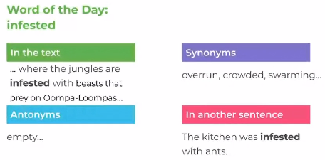

SPaG focus: inverted commas
What are inverted commas?
Inverted commas, also known as quotation marks or speech marks, are used at the start and end of direct speech to show that someone is speaking.
For example:
“I warned him not to touch anything,” sighed Mr. Wonka
“I want an Oompa-Loompa!” screamed Veruca. “Now!”
Inverted commas only surround the words that are being spoken.
A few rules:
- Inverted commas are used to highlight the words being spoken
  - “I’m hungry,” complained Emma.
- A new speaker needs a new line.
  - “How are you today?” asked Ms. Leonard.
“I’m great!” said Mrs. Cooke.
- Direct speech begins with a capital letter.
  - “What an amazing day!” he announced.
- Speech must be punctuated correctly- including punctuation before closing the inverted commas
  - “We have learnt so much today,” stated the delighted teacher.
- Include WHO is speaking and even think about HOW they are speaking
  - “I’m ready for bed,” murmured the tired, little boy.
- Reported speech does not need inverted commas. (There are no words being spoken, they have already been said.)
  - Emma explained that she was tired after her busy day.
Can you find examples of where we have used inverted commas in our Good Example text about Charlie and the Chocolate Factory? Think about who is saying it and which punctuation mark has been used before closing the speech marks.
Activity: These questions are based on ‘Grandma Grows Giant!’ from yesterday.
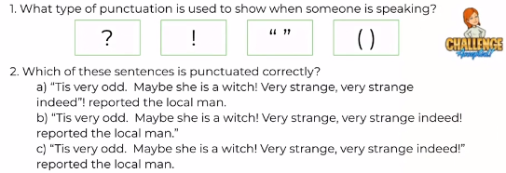
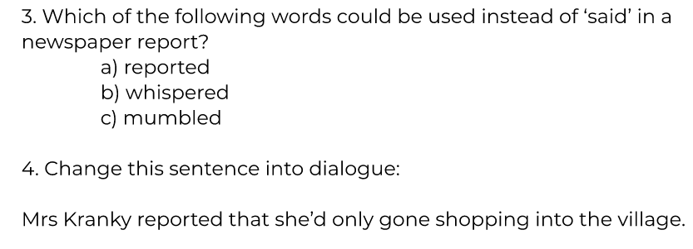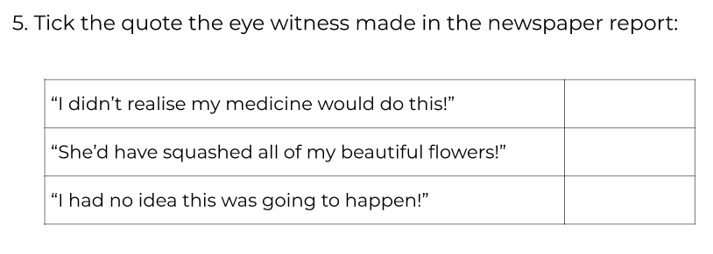
Answers:
- “ “
- C) “Tis very odd. Maybe she is a witch! Very strange, very strange indeed!” reported the local man.
- A) reported
- “I had only gone shopping into the village,” reported Mrs. Kranky.
- Middle one: “She’d have squashed all of my beautiful flowers!”

Friday
LO: I can write a news report
Word of the Day: distraught (adjective) -very worried and upset
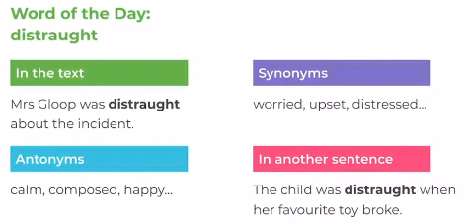
Today we are going to use the features we have learnt in the last few sessions to write a news report.
Your task: Read the new extract from Charlie and the Chocolate Factory and write your own news report. There are lots of quotes you could choose to include.
In this extract, Violet Beauregard grabs a piece of chewing gum that Mr. Wonka is working on and, against his instructions, pops it into her mouth.
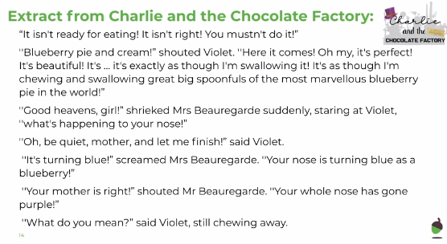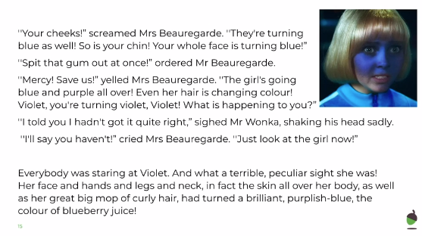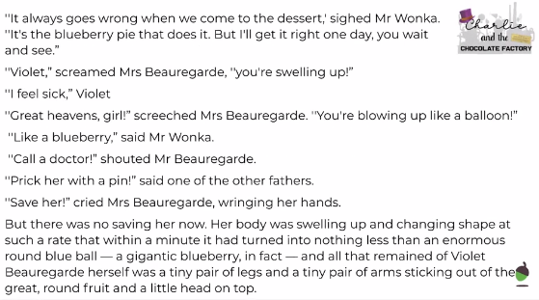
Independent Activity:
To turn the extract on Violet Beauregarde into a news report.
Structure:
- Write in 3rd person
- First paragraph: 5Ws (Who, What, Where, When, Why)
- Second paragraph: Mr. Wonka and his views
- Third/fourth paragraph: other eyewitness accounts
- Last paragraph: parent quotes
Don’t forget to think about:
- Headline, captions, columns
- Formal language
- Emotive language
- Expanded noun phrases to add detail
- Adverbs
- Correct use of inverted commas for quotes

First paragraph: think about the 5 Ws
- Who: Violet Beauregarde
- What: ate blueberry pie chewing gum and turned into a gigantic blueberry
- Where: inside Mr. Wonka’s chocolate factory
- When: during the visit for the five golden ticket winners
- Why: she chewed the gum despite Mr. Wonka’s warning that it wasn’t yet ready for eating
Words to replace ‘said’:
- Commented
- Claimed
- Reported
- Stated
- Exclaimed
- Declared
Useful phrases:
- Eyewitness say…
- It appears that…
- It has been reported…
- According to…
- Despite this, …
- It was discovered that…
- …explained to us…
- …told our reporter…
- In a statement…
- In an interview with…
- If you have any further information…
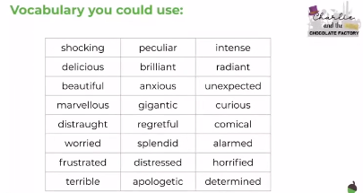

Have a great time writing your news report! I can’t wait to read them.

