Daily Lessons with Oak National Academy at https://www.thenational.academy/online-classroom/reception#schedule
Additional Activities
English and Literacy | Maths | Educational Online Games | Additional
Phonics with Ruth Miskin 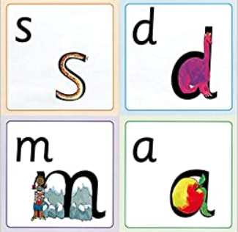  https://www.youtube.com/channel/UCo7fbLgY2oA_cFCIg9GdxtQ  Pinkcredible Story Maker 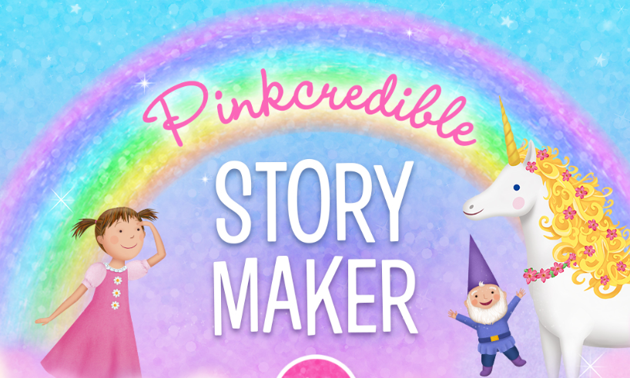  https://pbskids.org/pinkalicious/games/pinkcredible-story-maker  David Walliams Audio Stories  https://www.worldofdavidwalliams.com/elevenses/ | White Rose: Daily lessons  https://whiterosemaths.com/homelearning/early-years/  Numbots  Find your personalised login information on Tapestry.  https://play.numbots.com/#/intro | Busy things  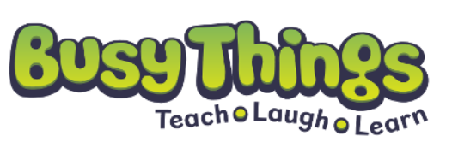  Username: home79  Password: red79  https://www.busythings.co.uk/play/  Espresso  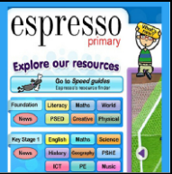  Username: student21443  Password: rps685  https://www.discoveryeducation.co.uk/what-we-offer/discovery-education-espresso/maths-resources  San Diego Zoo Games  https://kids.sandiegozoo.org/games | PE with Joe Wicks  https://www.youtube.com/playlist?list=PLyCLoPd4VxBvQafyve889qVcPxYEjdSTl  Cosmic Kids Yoga  https://www.youtube.com/user/CosmicKidsYoga  Twinkl: Free online and printable resources  Enter code: UKTWINKLHELPS  https://www.twinkl.co.uk/search  Covibook: A child-friendly way to discuss the coronavirus.  https://www.mindheart.co/descargables
BBC Bitesize Daily: Daily Lessons in all subjects
Online or on BBC iplayer
https://www.bbc.co.uk/bitesize/articles/z6vpnrd

