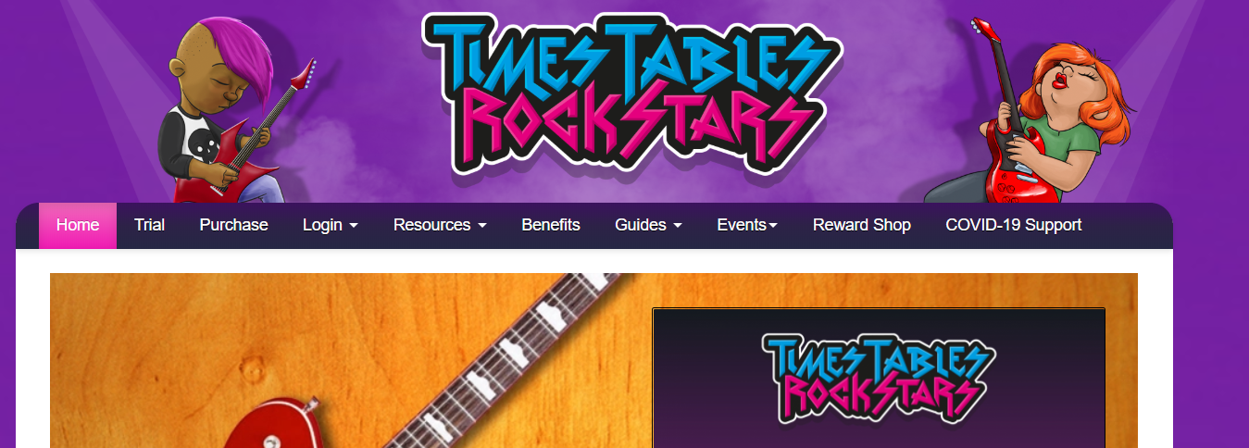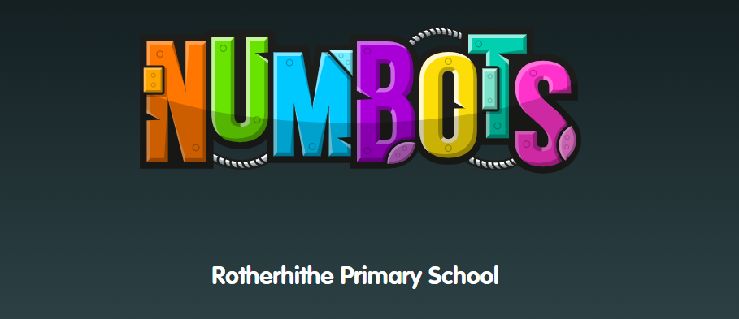
Please go onto Times Tables Rock Stars and Numbots using the pupil logins to help your child practice counting in 2s, 5s and 10s. They could also practice counting objects in your home. For example:
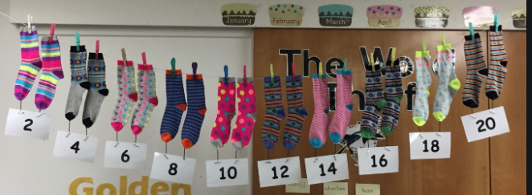
Ask your child to sort their socks by counting in 2s.

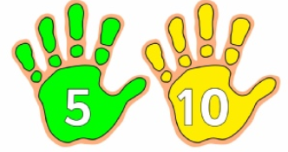How many times can your child draw around their hands? Ask them to count in 5s to see how many fingers they have drawn.
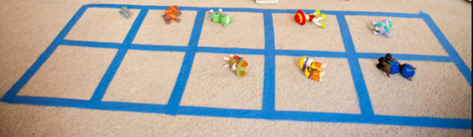
Why not try making and 10s frame out of tape or string and practice counting their toys in groups of 10.
They could also use Lego or blocks to practise. Have fun counting!

