Week 2 English
I can carefully read a book and write a book review
When authors write books people review them and rate them out of 5 stars and say why they like or don’t like the book. We would like you to choose a book and write a book review.
For example - I give this book 4/5
I liked/loved this book because…
My favourite character was …..
I would prefer ….
I would/ would not read this again because ….
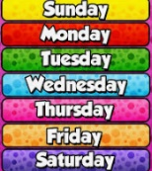
I can practise my spellings and handwriting.
Write each day of the week out 8 times into your book. Adults help your child to learn these spellings and check they are spelling them correctly during this weeks task.
Monday Tuesday Wednesday Thursday Friday Saturday Sunday
I can write my sentences using capital letters and full stops. I can use the past tense correctly in a sentence.
Use the following past tense words to write at least one sentence about what you have done each day.
went sat played ate surprised
Try and use adjectives to describe what you are writing about example: my red, fast car.
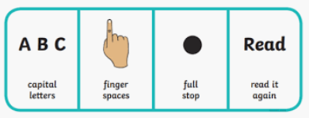
Remember to use capital letters, full stops and finger spaces.

Phonics As well as your phonics books practice playing Picnic on Pluto with Obb and Bob reading real words and nonsense words. Phonics play: https://new.phonicsplay.co.uk/resources/phase/2/picnic-on-pluto

