Where in the World?

Go onto Google Earth or Google Maps to look at the geographical features of…

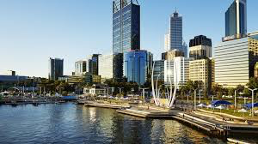
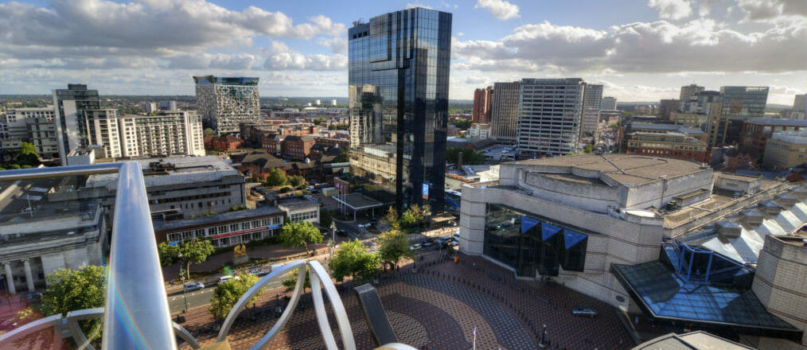
Birmingham Aberystwyth Perth (Australia).
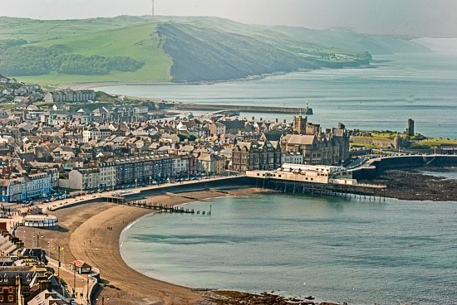

How are these places the same? How are these places different? What impacts the similarities and differences?

Similarities | Differences

Challenge: Now choose and compare three different locations. It could be anywhere in the world!

