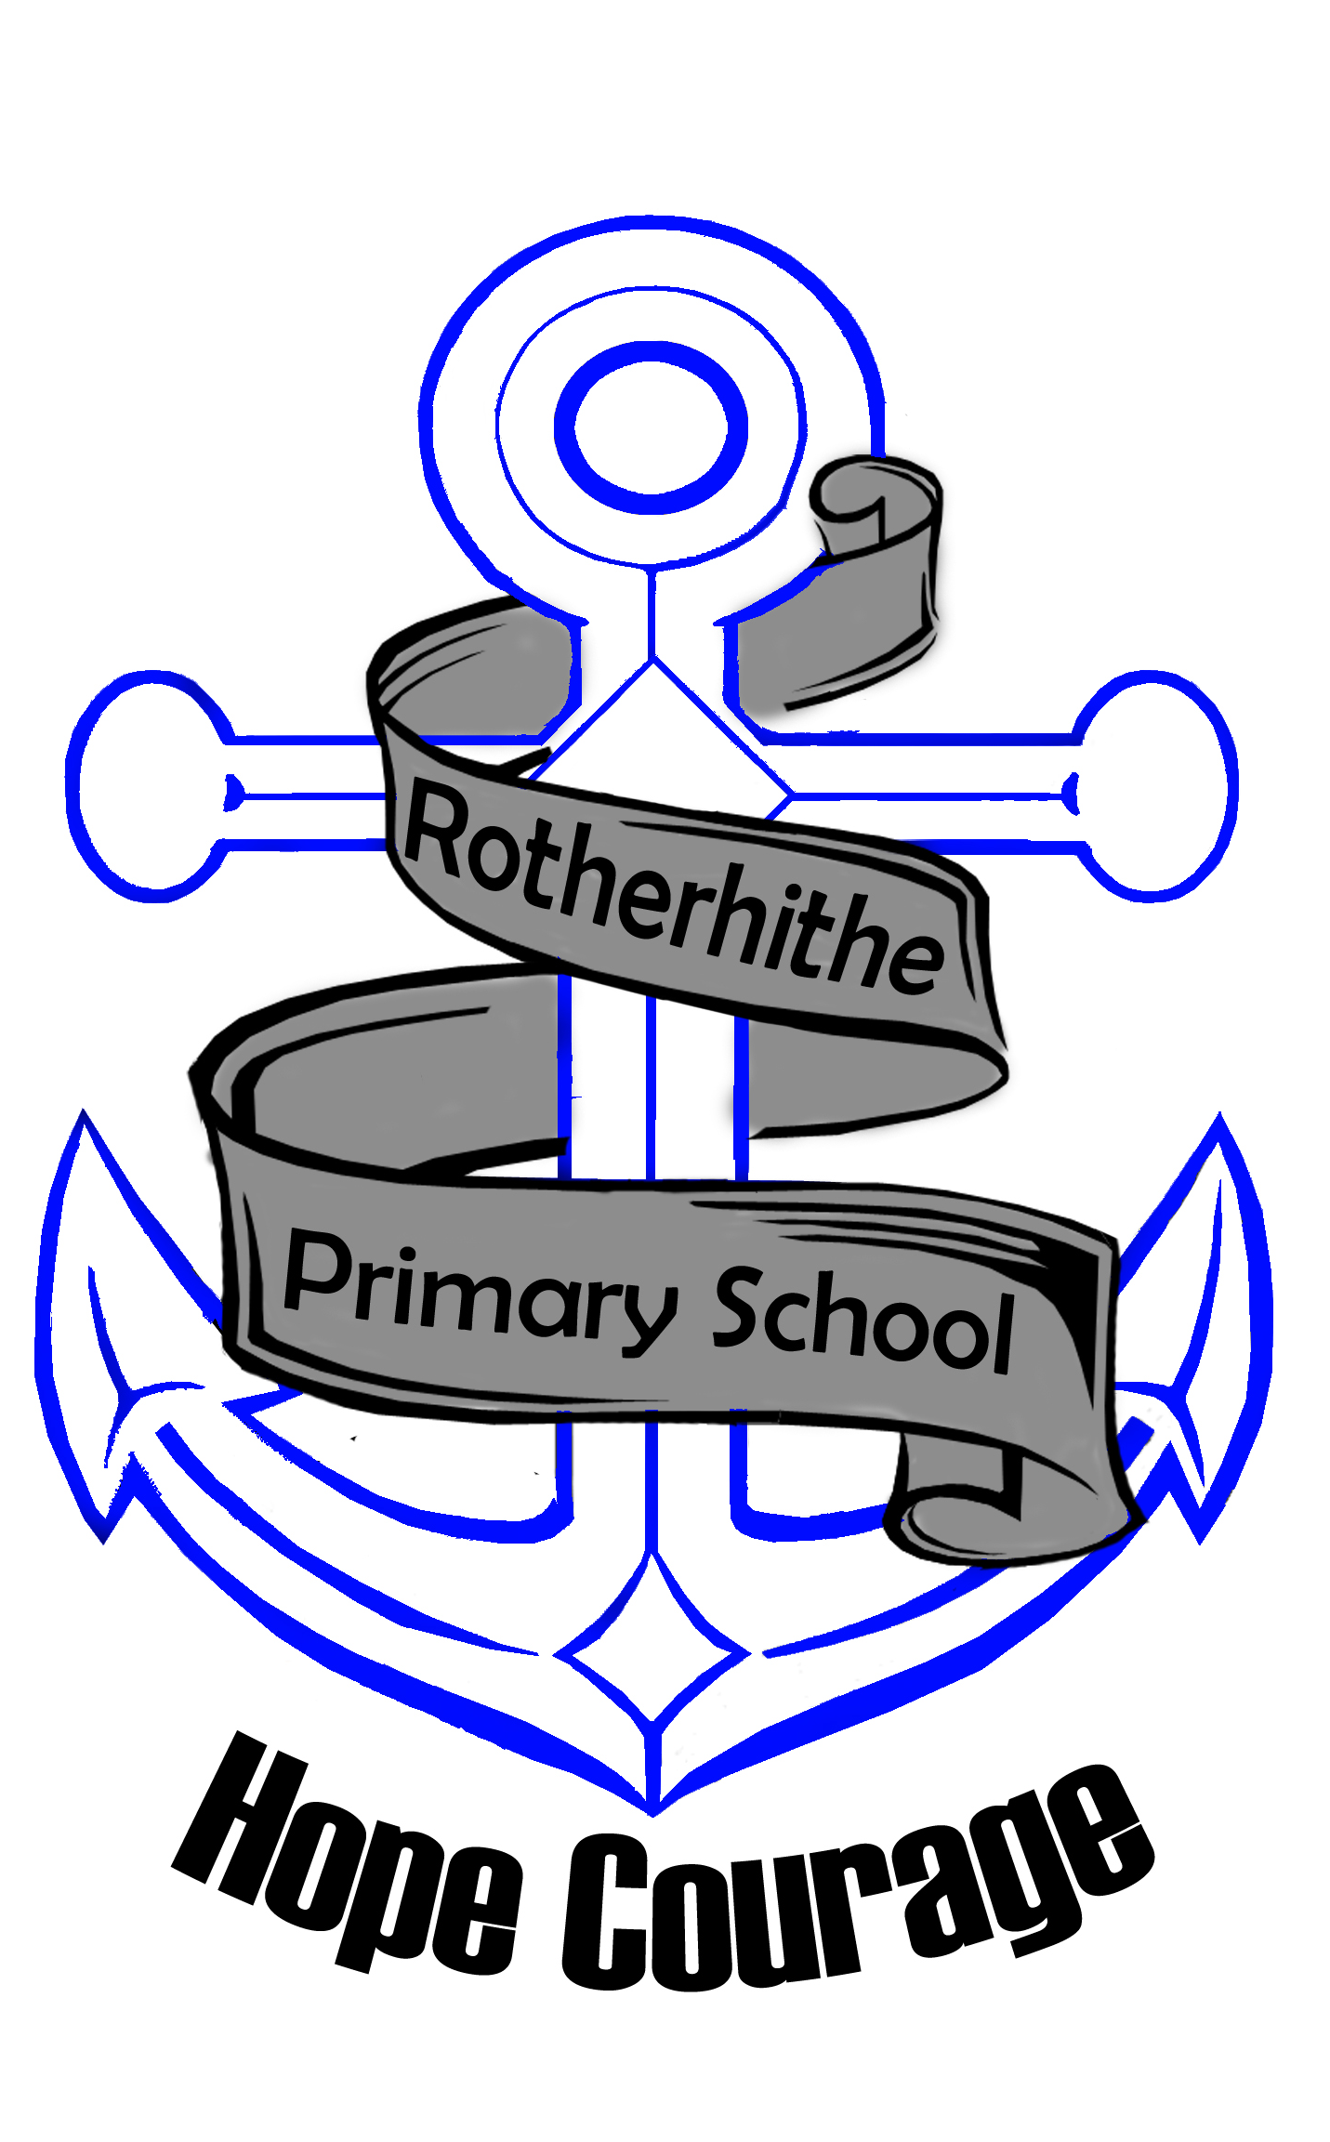

Rotherhithe Primary
Rotherhithe New Road
London
SE16 2PL
Tel: 0207 2371586
Fax: 0207 2373653
Email: office@rotherhithe.southwark.sch.uk

UNIFORM REMINDER

To all parents / carers

School uniform is an important aspect of who we are as a school community and we need your support in ensuring that your child / children come to school dressed in full school uniform.

Here is a reminder:

Shirts: Plain, white, cotton long/short sleeved shirt with collar or white polo t-shirt
Jumper: Blue school jumper / fleece with the school badge (available to purchase at the
school office)
Trousers: Grey Trousers – no tracksuit bottoms will be allowed from September onwards
Skirt: Grey, plain approximately knee length.
Headscarf: Plain black (if worn). White headscarves may be worn in summer. (In the interest of health and safety children will be asked to remove these during PE sessions. They will be allowed to wear a bandana for the session. )
Shoes: Must be completely black, flat shoes or completely black trainers with black laces.
Please note: no boots with heels, sling backs or sandals are allowed due to Health
and Safety in the playground.
Socks: Plain black or plain white ankle or knee length.
Tights: Grey or plain black thick tights to be worn under skirts.
School Bag: From September all children in year 1, 2 and 3 will need a school book bag. This is to
ensure that the school reading journal and homework is kept neat and presentable.
Children in Year 4, 5 and 6 can purchase their own back pack BUT it must be black.
No handbags will be allowed for girls. A suitable sized School bag (Book Bags
available to purchase at the school office)
Hair: Shoulder length or longer hair must be tied up with black or blue tidies
Nails: Should be kept clean and short enough to enable students to participate safely in practical activities. No coloured nail varnish is allowed.
Jewellery: Wrist watches may be worn if a child is able to tell the time. If desired one small earring, sleeper or stud in each ear only.

(The school does not accept responsibility for
the loss of any personal property)

COMPULSARY School Uniform
We expect all children to wear school uniform at all times. When a child is unable to wear the correct uniform, a parent/carer is required to send a note to the class teacher (with the child on that day) explaining the reason and the period for which this will occur. (Parents/carers are also asked to provide ‘replacement’ uniform items in colours and styles as close as possible to the original item.) Parents should be aware that their child will be challenged if they are not wearing the correct uniform.

PE Kit
We ask that ALL children wear appropriate clothing for PE. We recommend dark bottoms (black or navy) and white PE t-shirts. These can be purchased at the front office on Fridays.

If your child does not have a kit, s/he will be offered washed and clean kit so that s/he is able to take an active part in the lesson with safety. You are requested to wash and return these the next day.

If your child cannot participate in the lesson due to illness or injury, then a letter from home is required to be given to the class teacher on the day. Your child should still bring his / her kit and change, as there are many other roles s/he can adopt, such as coach, umpire or score keeper.

All teachers and senior leaders will be following up on the correct uniform for the rest of the term and continue to do so for September. We are giving parents 2 months’ notice to purchase the correct uniform, shoes and PE kit.

Please ensure that your child is appropriately dressed and follows the school uniform of Rotherhithe Primary.

Kind Regards,

………………………….
Galiema Amien – Cloete
Executive Head Teacher

