ROTHERHITHE PRIMARY SCHOOL
School Closure Weekly Timetable
Year 3- Pearl and Endeavour

Subject | Monday | Tuesday | Wednesday | Thursday | Friday
English  Everyday:  Reading (20-30 mins)  https://home.oxfordowl. co.uk/reading/  Handwriting practise (Twinkl Common Exception Words):  https://www.twinkl.co.u k/resource/year-3-year- 4-statutory-spelling- words-handwriting- activity-sheets-t-e- 2549615  Spelling Task: http://www.ictgam es.com/mobilePag e/lcwc/index.html  Phonics (If your child usually has additional phonics sessions):  https://www.phonicspla y.co.uk/#  Username: march20 Password: home | Writing Task: Poetry  In this lesson, we are going to explore the meaning of words using a poem.  https://www.thenational.academy/year-3/english/poetry-reading-comprehension-word-meaning-year-3-wk3-1  Comprehension Task:  https://www.oxfordowl.co.uk/api/interactives/24507.html | Writing Task: Poetry  In this lesson, we are going to explore inference questions using a poem.  https://www.thenational.academy/year-3/english/poetry-reading-comprehension-inference-year-3-wk3-2  Comprehension Task:  https://www.oxfordowl.co.uk/api/interactives/24496.html | Writing Task: Poetry  In this lesson, we are going to explore the features of a poem.  https://www.thenational.academy/year-3/english/poetry-identifying-the-features-of-a-text-year-3-wk3-3  Comprehension Task:  Choose a new book and answer the following questions:  - Does the title suggest anything about the book?  - Do you have any expectations about the book?  - Can you predict what will happen  in the book?  Optional free eBooks  https://home.oxfordowl.co.uk/books/free-ebooks/  https://www.twinkl.co.uk/search?term=e+books | Writing Task: Poetry  In this lesson, we are going to explore the features of a poem.  https://www.thenational.academy/year-3/english/poetry-spag-focus-expanded-noun-phrases-year-3-wk3-4  Comprehension Task:  Begin reading your book and answer the following questions:  • Are there any word you have found that you did not know before?  • What are your thoughts about the main character? | Writing Task: Poetry  In this lesson, we are going to plan and write a sound poem.  https://www.thenational.academy/year-3/english/poetry-write-a-sound-poem-year-3-wk3-5  Comprehension Task:  Continue reading your book and answer the following questions:  • How does the author keep the readers attention?  • How do you thin the story will end now that you have read more of the story?  • What question would you aks the author about what you have read so far?
Maths | Times Table Rock Stars  https://ttrockstars.com/  Mental Arithmetic  https://www.topmarks.co  .uk/maths-games/daily10  Chose Level 3 – Digit Values  Maths with oak academy  In this lesson, we will use our knowledge of fractions to understand what the term 'non-unit fraction' means. We will explore various shapes and begin to identify the non-unit fraction that is represented.  https://www.thenational.academy/year-3/maths/identify-and-describing-non-unit-fractions-year-3-wk2-1 | Times Table Rock Stars  https://ttrockstars.com/  Mental Arithmetic  https://www.topmarks.co  .uk/maths-games/daily10  Chose Level 3 – Digit Values  Maths with oak academy  In this lesson, we will revisit what a non-unit fraction is. We will then use a ‘bar modelling’ strategy to help us calculate non-unit fractions of amounts. Finally, we will then work backwards by applying this knowledge to use the value of the parts to help us calculate the total value of the quantity (whole). https://www.thenational.academy/year-3/maths/finding-non-unit-fractions-of-quantities-year-3-wk2-2 | Times Table Rock Stars https://ttrockstars.c om/  Mental Arithmetic https://www.topm arks.co.uk/maths- games/daily10  Chose Level 3 – Multiplication (chose the multiples you are working on)  Maths with oak academy  In this lesson, we will consolidate the learning from Lesson 4 and Lesson 7. We will be using our multiplication and division facts to become more confident with finding non-unit fractions of amounts. Today, we will only use the ‘bar modelling’ strategy to represent our procedure.  https://www.thenational.academy/year-3/maths/consolidating-finding-non-unit-fractions-of-quantities-year-3-wk2-3 | Times Table Rock Stars https://ttrockstars.co m/  Mental Arithmetic  https://www.topmarks  .co.uk/maths- games/daily10  Chose Level 3 – Multiplication (chose the multiples you are working on)  Maths with oak academy  In this lesson, we will start to use pictorial representations to help identify and compare the size of fractions with the same denominator. We will then apply this learning to think more abstractly about what procedure is used to compare fractions with the same denominator.  https://www.thenational.academy/year-3/maths/comparing-fractions-with-the-same-denominator-year-3-wk2-4 | Times Table Rock Stars  https://ttrockstars.com/  Mental Arithmetic https://www.topmarks. co.uk/maths- games/daily10  Chose Level 3 – Multiplication (chose the multiples you are working on)  Maths with oak academy  In this lesson, we will explore the size of different unit fractions. We will compare and order these fractions, focusing on their denominators before we apply this knowledge to compare unit fractions of the same quantity.  https://www.thenational.academy/year-3/maths/compare-and-order-unit-fractions-year-3-wk2-5
Indoor Exercise | Cosmic Kids Yoga  https://www.youtube.co m/user/CosmicKidsYoga  Joe Wicks  https://www.youtube.com/playlist?list=PLyCLoPd4VxBvQafyve889qVcPxYEjdSTl  Go Noodle:  https://www.gonoodle.com/ | Just Dance Kids https://www.youtube.com/watch?v=ziLHZeKbMUo  Joe Wicks https://www.youtube.com/playlist?list=PLyCLoPd4VxBvQafyve889qVcPxYEjdSTl  Go Noodle:  https://www.gonoodle.com/ | Cosmic Kids Yoga  https://www.youtube.com/user/CosmicKidsYoga  Joe Wicks  https://www.youtube.com/playlist?list=PLyCLoPd4VxBvQafyve889qVcPxYEjdSTl  Go Noodle:  https://www.gonoodle.com/ | Just Dance Kids  https://www.youtube.com/watch?v=ziLHZeKbMUo  Joe Wicks  https://www.youtube.com/playlist?list=PLyCLoPd4VxBvQafyve889qVcPxYEjdSTl  Go Noodle:  https://www.gonoodle.com/ | Cosmic Kids Yoga  https://www.youtube.com/user/CosmicKidsYoga  Joe Wicks  https://www.youtube.com/playlist?list=PLyCLoPd4VxBvQafyve889qVcPxYEjdSTl  Go Noodle:  https://www.gonoodle.com/
Foundation Subjects | Science  Different properties of rocks.  Use the information to fill in the table about rocks.  Fill it in on the computer or draw the table into your book!  Once you have finished you can find some rocks yourself!  Find them and try to classify and describe them using the language in the table! | Geography  We live in London!  Can you research where there were Stone Age communities in London?  Can you research as much information about them as possible!  Why were they in the area of London?  Make notes in your book! | History  Use the information sheet to answer some questions about different types of Stone Age homes!  How are they different to where you live?  How are they similar?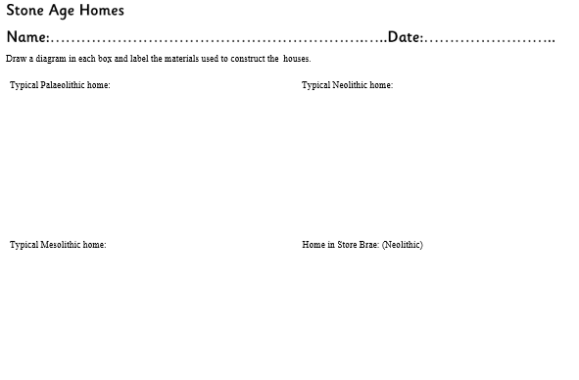 | Art/ DT  Stone Age house were made from the materials that people found around them. You can collect twigs to make the structure and cover it with moss or fur fabric to create your own model house.  Task:  Create a Stone Age house model  (see worksheet on the school website)  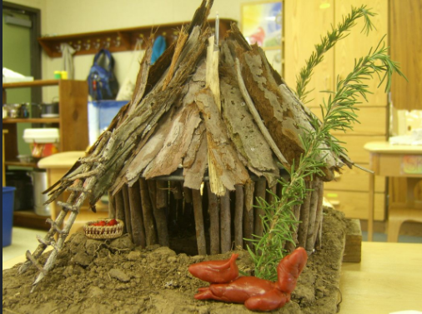 | Music  - https://www.bbc.co.uk/bitesize/subjects/zwxhfg8  - http://creatingmusic.com/BlockGames/3×3/  - http://www.musicgames.net/livegames/orchestra/orchestra2.htm  - https://www.musicteachers.co.uk/resources/funstuff
Project work/  PSHE/Citizenship  Work/PSHE/citizens hip  Everyday: https://www.skills builder.org/home learning | Let’s Wonder:  Think about your street. What type of houses / flats are on your street? What type  of place do you live in? What other buildings are close by? Find out about the local area, what is there? How old are some of those buildings? What other  spaces are there? How have they changed over time? Use a map to locate different places. Look on Google Earth. Draw your own map of the local area. | Let’s Create:  Choose a building you like in the local area. Make a model of that building using materials of their choice. (Playdough, junk modelling, lego etc…..) How well did you do? What would you do differently next time? What have you learnt? | Time to Talk:  Were family members all born in this local area? If not, how is their place of birth different to their own local area? If they were, how different is the local area since they were born? Talk about  their memories of how it has changed. | Understanding Others and Appreciating Differences:  Research different places of worship that can be found in the local area. Can you find the nearest Church?  Mosque? Synagogue? Temple? Gurdwara? What can you find out about them? Draw  pictures and label them with any information they find out. | Reflect:  Think about what would improve the local area? What is the local area lacking? What spoils the local area? What could be done? Design a new and improved one, maybe including more green space, a specialist shop or something else you’d like.
Mindfulness/  Wellbeing  Other options: Headspace: (free) https://www.headspace. com/subscriptions  Breath and Body: https://it.pearson.com/c ontent/dam/region- core/italy/pearson- italy/pdf/Docenti/breath_and_body.mp3  Mindful colouring from Twinkl | One Minute Mindful Seeing  Find a place where there are lots of things to see.  e.g. out of a window.  For one minute, observe all the things you can see and make a list. Is there anything new that you’ve noticed that you haven’t seen before? | Practice Star Breathing  Start at a point on a star, follow your way around with your finger breathing slowly and holding your breaths at the points.  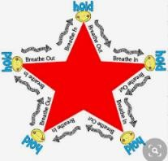 | One Minute Mindful Smelling  Take a minute to focus on smells around you. It might be when there is cooking going on or when you are going for a walk.  Focus on how many different smells you can identify. How did they make you feel? Did you have a favourite smell? | Teddy Bear Belly Breathing  Lie with your back on the floor and put a soft toy on your belly.  Breathe in and out slowly. Try and concentrate on the way your toy rises and falls with your breathing. | Practice ‘Take 5’ Breathing  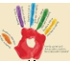  Hold your hands out and spread your fingers. With the finger of the other hand, trace the outline of a finger breathing in through your nose as you trace up.  Breathing out through your mouth  as you trace down. Keep going at a steady pace.

