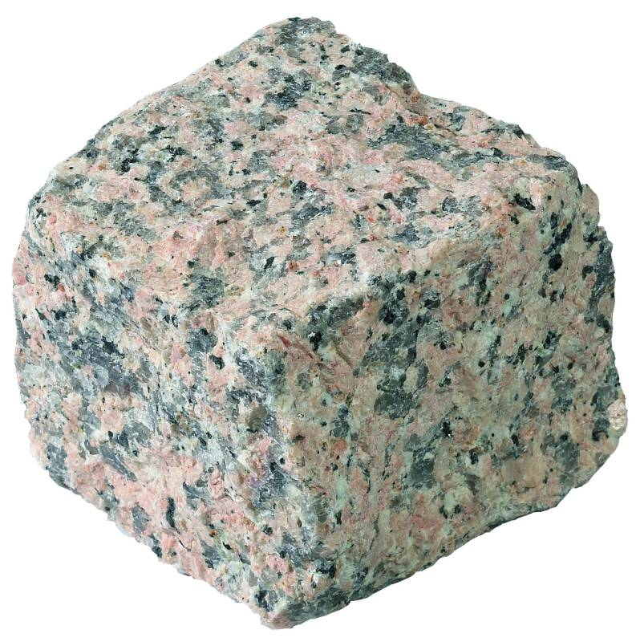

First look at the PowerPoint named Comparing Rocks
Main Task
Complete the table below comparing the three types of rocks. Use the rock identification sheet (see school website) to help you note the characteristics.
The first one has been started can you complete it by adding additional characteristics?
Type of Rock | Igneous | Metamorphic | Sedimentary
Example | Granite
Picture  Can you draw a picture of you chosen rock? | 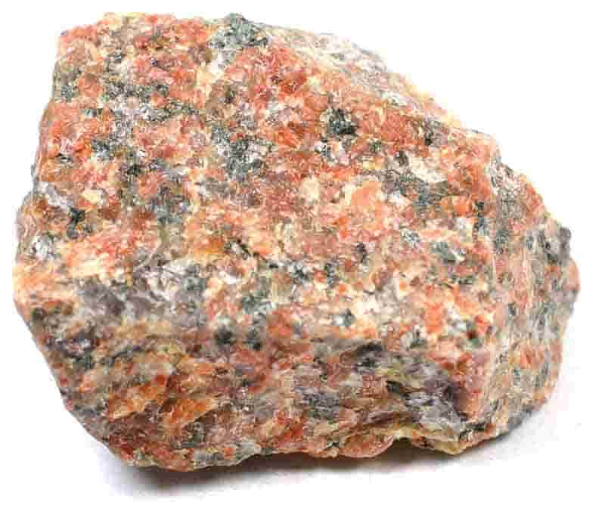
Characteristics | - Hard  - Large crystals

