THE MAGIC BOX
I will put in the box
the swish of a silk sari on a summer night,
fire from the nostrils of a Chinese dragon,
the tip of a tongue touching a tooth.
I will put in the box
a snowman with a rumbling belly
a sip of the bluest water from Lake Lucerene,
a leaping spark from an electric fish.
I will put into the box
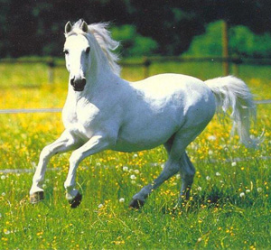
three violet wishes spoken in Gujarati,
the last joke of an ancient uncle,
and the first smile of a baby.
I will put into the box
a fifth season and a black sun,
a cowboy on a broomstick
and a witch on a white horse.
My box is fashioned from ice and gold and steel,
with stars on the lid and secrets in the corners.
Its hinges are the toe joints of dinosaurs.
I shall surf in my box
on the great high-rolling breakers of the wild Atlantic,
then wash ashore on a yellow beach
the colour of the sun.
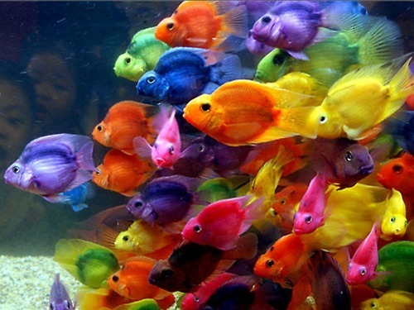
by Kit Wright

Monday
LO: I can discuss language for effect.
Follow this link: https://www.thenational.academy/year-4/english/poetry-reading-comprehension-word-meaning-year-4-wk1-1#slide-3
You will need a paper and a pen/pencil. Complete the activities in the video which are all focused around the poem, ‘The Magic Box’ by Kit Wright. Remember to listen carefully!

Tuesday
LO: I can answer questions based on a poem.
Answer these questions using the text to support you answer. Remember the highlight the word, or the group of words, which help you find your answer in the text with a pencil or a highlighter (just like we do in class!).

- Find and copy a group of words which are repeated in the poem.

- Write down two ways in which the poet describes in the box.

- Why do you think the box is described as magic? Don’t forget to structure your answer using the sentence stems below:
Because the text says…
This suggests that…

- Which verse is your favourite and why?

- Draw a picture to show what you think the box looks like.

Wednesday
LO: I can design my own magic box.
What will you put into your box? Remember to use: powerful adjectives, alliteration and a challenge you to use a simile!
- What about sounds, smells and textures?
- What sort of foods would go in?
- What colours and weather?
- What sort of dreams go in, and what sort of feelings?
- Are there things from the natural world, like rivers and mountains?
- Perhaps it has a window in it, or a door leading to somewhere else?
- What is it made from?

The delicate dance of autumn leaves,

Thursday
LO: I can use descriptive devises in a poem.
Write poem similar to the one we just read, describing your own box. Use the plan you created yesterday!
Include the following:
- Metaphors/Similes
- Alliteration
- Powerful adjectives
Remember, you want your reader to know that this box is special and magical, so use your writing to show this! Wow your reader!

Friday
LO: I can perform a poem out loud.
Practise saying your poem out loud. Does it flow well? Could you make any improvements? Perform your poem to, or with, a member of your family and ask for feedback (two stars and a wish!). Don’t forget to perform your poem clearly and confidently. I can’t wait to read your poems – please ask your parents nicely to send me your poems over email.

