Monday: 4-digit place value (See Monday’s video on Maths with Parents)

- Here are the distances in km from London to various cities in the world. Sort out these journeys in order according to the distances involved.
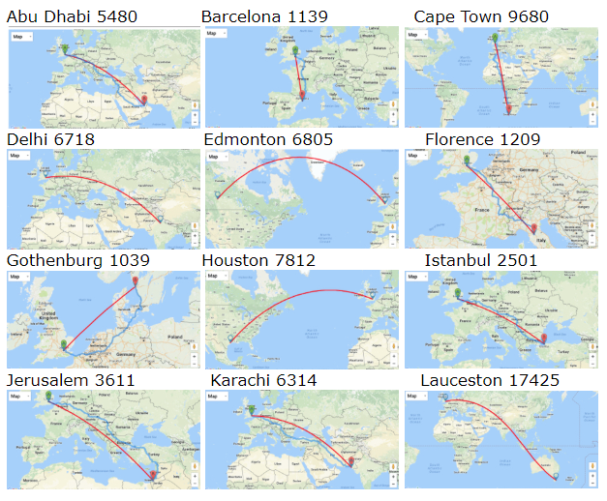

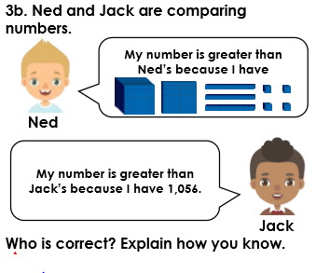

For fun:
Play Place Value Battle:

Each player should draw a set of 4 squares next to each other on a piece of paper, as if you were going to write a 4-digit number.
Version 1 (friendly game):
Players take it in turn to roll the 0-9 die and write it on their chosen place value square. The aim of the game is to be the player with the greatest 4-digit number at the end of the game. Good luck!
Version 2 (nasty version):
The game is played as above but this time a player can also place their number on one of their opponent’s place value squares, if they would like to.

Tuesday: 4-digit place value (See Monday’s video on Maths with Parents)
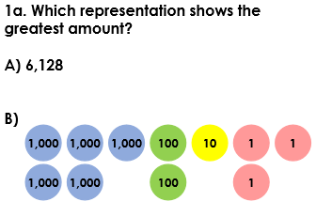

2. Compare and order these numbers from smallest to largest.
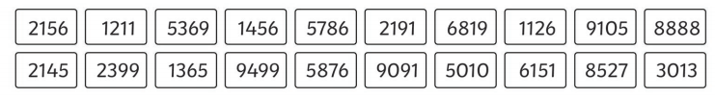

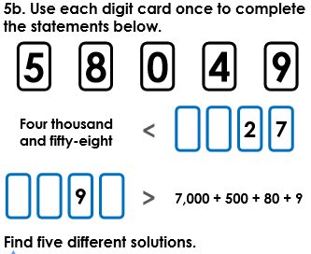

Wednesday: Rounding to 10s (See Wednesday’s video on Maths with Parents)
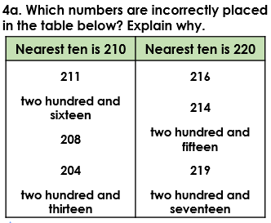

- A) Round each of the numbers 42 and 34 to the nearest 10. Now add both your rounded numbers together and write down the answer.
B) Add the numbers 42 and 34 without rounding them. Take your answer and round it to the nearest 10. Write down the answer.
C) What do you notice about the two answers? Are the two answers always different? Can you find another example with new numbers?

Thursday: Rounding to 100s (See Wednesday’s video on Maths with Parents)
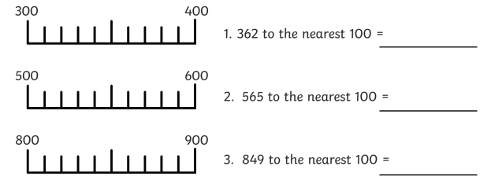

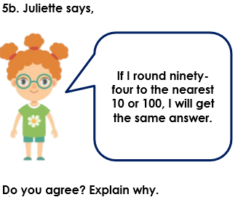

Friday: Rounding to 1000s (See Wednesday’s video on Maths with Parents)
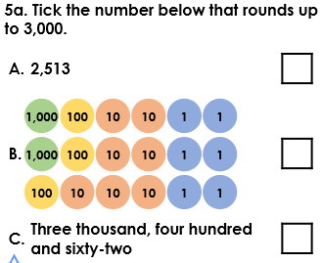

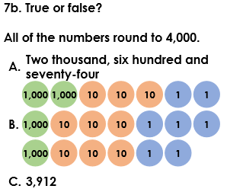

Rounding Challenge: