**Each day gets progressively harder. Do not skip a day as you will need the learning from the previous day to understand the day after – do them in the correct order. There are three challenges per day. Each one gets a little harder, so start with the first and work your way down. Don’t panic if you can’t do them all. Watch the video again and as an adult for help.**

**Place value chart to help you picture the place value of tenths and hundredths:**

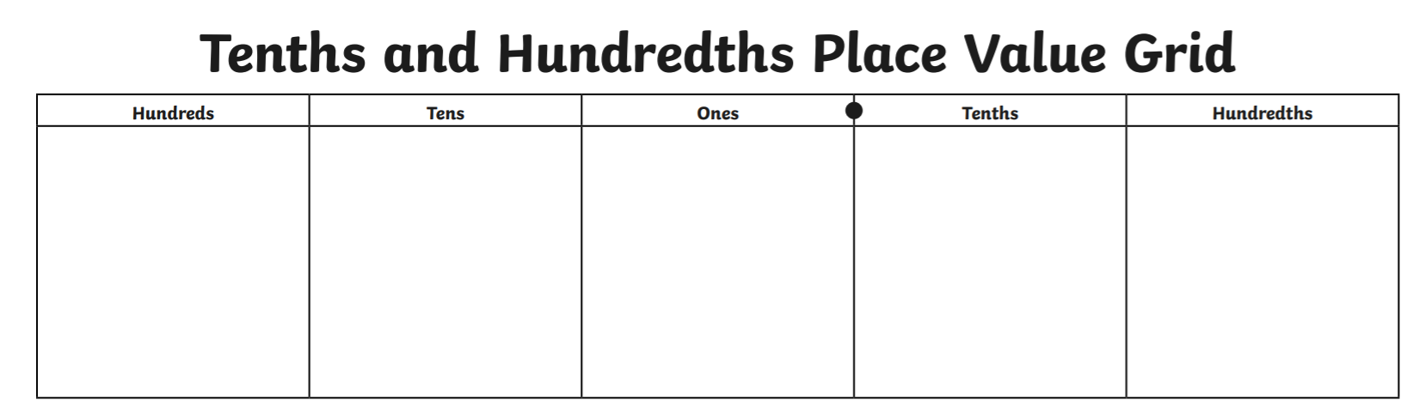

**Monday: Place value with tenths**

**Watch the video ‘Place Value with Tenths’ on maths with parents. Complete the activities below. Remember you can watch the videos lots of times!**

Practise

Fill in the blank boxes or images.

|  |  |  |
| --- | --- | --- |
| **Image** | **fraction** | **Decimal** |
|  |  |  |
|  | $$\frac{6}{10}$$ | **0.6** |
|  |  | **0.5** |

Apply

Draw an arrow to show where 0.7 would be placed on the number line.

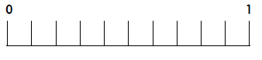

Reasoning

Peter is thinking of a number.

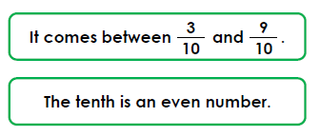

Write down 3 possibilities that Peter’s number could be using decimals.

Challenge

What is the difference between six tens and six tenths?

Show me.



**Tuesday: Place value with hundredths**

**Watch the video ‘Place Value with Hundredths’ on maths with parents. Complete the activities below. Remember you can watch the videos lots of times!**

Practise

What is the value of the ‘4’ in each number?

2.41

12.14

14.56

48.9

Apply

Can you partition these numbers into a place value addition?

e.g. 1.87 = 1 + 0.8 + 0.07

1. **3.56**
2. **12.89**
3. **9.03**
4. **56.43**

Reasoning

Hans and Penny are partitioning a number. Who is correct? Explain why.

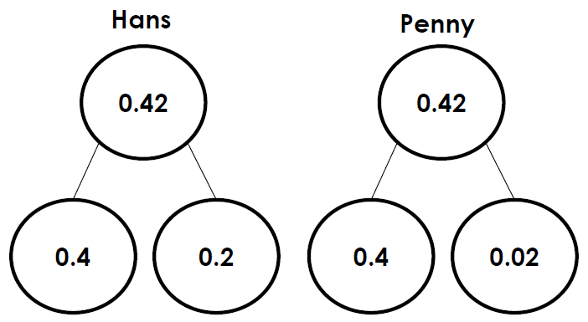

Challenge

What is the greatest number you can make?

What is the smallest number you can make?

You must use all the counters and have a counter in each column.

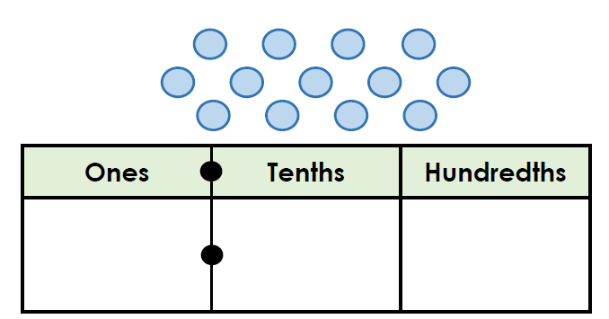

**Tuesday: Place value with hundredths**

**Watch the video ‘Place Value with Hundredths’ again on maths with parents. Complete the activities below. Remember you can watch the videos lots of times!**

Practise

Compare these decimals using <, > or =.

£1.23 £1.32

£2.04 £2.40

£3.11 £2.89

Apply

Order these lengths largest to smallest.

**2.09m 1.11m 1.1m**

Order these decimals smallest to largest.

**1.6km 1.16km 1.61km**

Reasoning

Is this statement correct? **Explain your answer.**

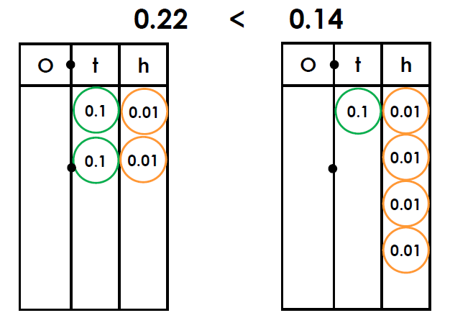

Challenge

Use the number cards to make decimal numbers which are less than one.

How many possibilities are there?

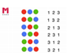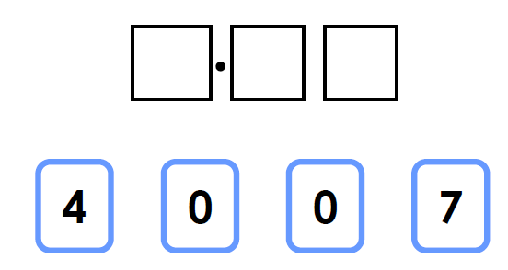

**Thursday: Rounding decimals**

**Watch the video ‘Rounding Decimals’ on maths with parents. Complete the activities below. Remember you can watch the videos lots of times!**

I want to round 2.3m to the nearest meter. I can use a number line to help me.

2 2.3 3

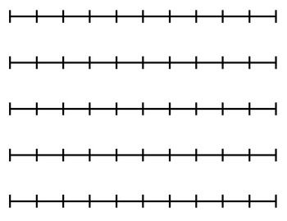

**2.3 rounded to the nearest whole number is 2.’**

Practise

Use the numberline to round these numbers to the nearest whole number.

1.5



3.7



4.9

Apply

Round these numbers to the nearest whole number.

**1.2 3.4 6.8 9.5**

Challenge

Ellis is thinking of a decimal. What could his number be?

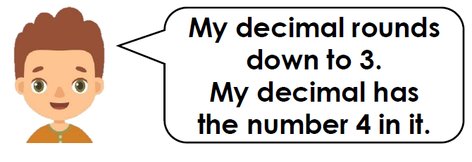

**Friday: Rounding decimals**

**Watch the video ‘Rounding Decimals’ again on maths with parents. Complete the activities below. Remember you can watch the videos lots of times!**

Practise

Use the numberline to round these numbers to the nearest whole number.

1.5m



£3.70

Apply

Round these numbers to the nearest meter.

**1.2m 3.4m 16.8m**

Round these values to the nearest pound.

**£3.45 £2.81 £11.04**

Reasoning

Challenge

Joanne is thinking of a decimal. What is her decimal?

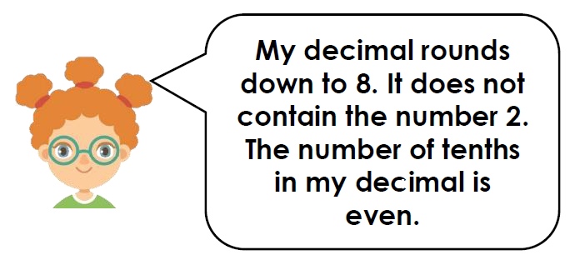

Two busses are different lengths. The lengths both

round to 6m. Is what the bus mechanic says possible?

Explain your answer. 