Henry VIII (Lesson 3)
Henry’s Great Matter
A special court at the Blackfriars was set up to hear the case. Henry claimed that the marriage had never been valid and should be annulled on religious grounds, quoting a passage from the Bible, which said that it was unlawful for a man to marry his brother’s widow. He claimed that his lack of a son was proof of God’s punishment for his unlawful marriage. Catherine bravely defended herself and the validity of her marriage to Henry citing another passage from the Bible, which said that a man could, and indeed should, marry his brother’s widow. When the court failed to reach a conclusion, Henry was furious, and blamed Wolsey. Henry was quick to take his revenge. Wolsey was accused of treason, but died before he could come to trial.
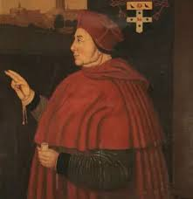
Henry decided to take matters into his own hands and to proceed without the Pope. He selected two men to help him: Thomas Cranmer and Thomas Cromwell. Cranmer was one of a group of reforming Protestant priests sympathetic to the king’s cause. In 1533, Henry appointed him Archbishop of Canterbury. Cranmer married Henry and the now pregnant Anne in a secret ceremony, and pronounced Henry’s marriage to Catherine null and void. Anne was then crowned queen.
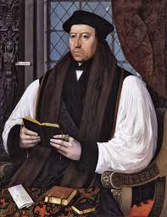

Comprehension Questions:
- What was discussed at the Blackfriars court?
- Whom did Henry blame for the failure of the court to reach a conclusion?
- Who became Archbishop of Canterbury in 1533?
Vocabulary Activities:
- Which of these words or phrases most closely matches the meaning of the phrase ‘null and void’?
  - Having no legal force
  - Aggressive
  - Quiet
- Using a thesaurus, find and write down at least one synonym of each of the following words:
  - Vivacious
  - Valid
  - Headstrong
  - Reform

