Henry’s six wives
‘Divorced, beheaded, died; divorced, beheaded, survived’ is the rhyme often used to help remember the order and fate of the six wives of Henry VIII. The fate of Catherine of Aragon, Henry’s first wife, was the most significant from an historical point of view because of the far-reaching effect it had on the country. Henry had great difficulty in securing this divorce; it became known as his ‘Great Matter’.

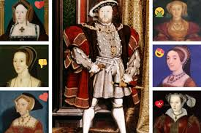

Catherine of Aragon
Catherine of Aragon was a Spanish princess who had grown up in the beautiful Alhambra Palace in Granada. Her parents, King Ferdinand of Aragon and Queen Isabella of Castile, had arranged a marriage for her with Henry’s older Brother, Arthur, who was heir to the English throne.

Catherine was sent as a teenage bride from the warmth of southern Spain to the colder, damper air of England. After four months of marriage, Arthur died and Catherine was left languishing in England, waiting for her parents to pay her marriage dowry so that she might return to Spain.
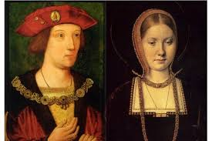
She never did go home. When Henry came to the throne in 1509, he married her. Initially, the marriage was a happy one; Catherine was a kind and loving wife, and Henry was an attentive husband, However, as time went on, Henry grew increasingly frustrated that he had no son. The only child to survive infancy was their daughter Mary.

Anne Boleyn
Henry was a headstrong and determined king, with a fiery temper and a huge appetite for life. He was used to getting his own way and doing as he pleased. Henry desperately wanted a son to continue the Tudor dynasty (a line of hereditary rulers of a country) that his father had founded. By 1527, after eighteen years of marriage, it was becoming clear that Catherine was too old to give him a son. Moreover, Henry’s attentions had been captured by one of the younger ladies at the court: Anne Boleyn. Anne was English, but she had spent some time at the French court, where she had developed a sophisticated and elegant manner. She was clever, well-read and extremely vivacious. Henry was smitten. He became determined to marry her.

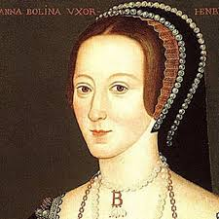

Comprehension Questions:
- How many wives did Henry VIII have?
- Who was Catherine of Aragon’s first husband? What was the relationship between Catherine of Aragon’s first husband and Henry?
- Why did Henry want a son?
- What was Henry’s ‘Great Matter’?
- When did Henry and Catherine marry?
Vocabulary activities:
- Which of these words or phrases most closely matches the meaning of the noun ‘divorce’?
  - The end of a marriage
  - A wedding
  - A husband
- Which of these words or phrases most closely matches the meaning of the noun ‘dynasty’?
  - An empire
  - A throne
  - A line of hereditary rulers of a country

