Arctic Fox
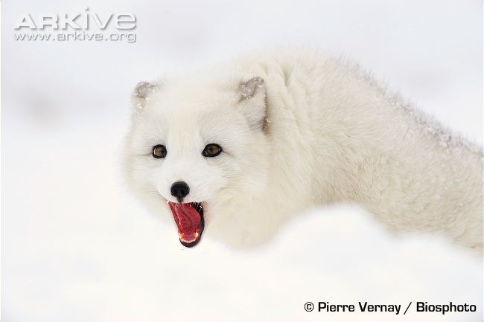
The Arctic fox (Vulpes lagopus) is superbly adapted for life at sub-zero temperatures. While this species is best known for its pristine, white winter coat, during the summer, the coat becomes brown on the upperparts, with light grey or white underpart, and is half as thick.

In addition, to the ‘white’ form of Arctic fox, a ‘blue’ form also occurs, which in some areas is light brown with a bluish sheen in the winter or dark brown to black in other areas, but becoming chocolate brown in the summer.

The dense, woolly coat of this species has the best insulating properties of all mammals, and helps this species survive at temperatures of -50 degrees Celsius in the wild. Some other adaptations for life in the Arctic include small, heavily furred ears and a short nose to reduce heat loss, as well as fur on the soles of the feet, and increased blood flow to the feet pads to prevent freezing.

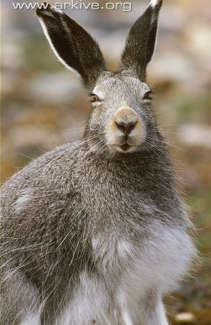
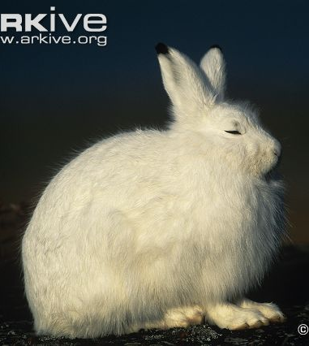
Arctic Hare
One of the world’s largest hares, the Arctic hare (Lepus arcticus) has a distinctive, uniformly white summer coat, aside from the tips of each ear, which are black. The thick white fur provides both warmth and camouflage against the Arctic hare’s snowy surroundings. After the spring moult, the fur of some arctic hares is replaced with a shorter grey-brown fur.
The female Arctic hare is larger than the male, and also begins to moult earlier in spring.
The Arctic hare has very thick fur and quite a large, compact body compared with other hare species. The small size of the ears and other parts of the body (e.g. feet) helps to reduce heat loss in cold conditions, while the paws are heavily padded with thick, coarse fur which helps the Arctic hare to walk on the surface of snow without sinking. The well adapted claws and incisors (pointed teeth) enable the Arctic hare to dig through snow and feed on the plants beneath.
Distress calls are made by hare and rabbit species when they are caught by predators, but all other communication is thought to be done by scent marking.
Emperor Penguin
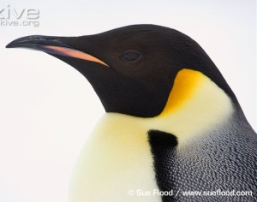

Standing over a metre in height and weighing up to 40 kilograms, the emperor penguin (Aptenodytes forsteri) is the undisputed heavyweight of the penguin world. Slow and dignified, the emperor penguin is a stunning bird with a blue-grey back that shades into a black tail, and a characteristically white belly flushed with yellow. Deep yellow ear patches on either side of the head fade down the neck and the upper chest, while the remainder of the head and throat is black.

In order to limit heat loss, the emperor penguin’s extremities are reduced in size, with a small head and bill relative to body size, and flippers that are proportionately 25 percent smaller than those of other penguins.

A specially designed circulatory system also provides an efficient way to keep heat within the body. Furthermore, the scale-like feathers of the emperor penguin are tightly packed in multiple layers that only the harshest winds can ruffle, while the feet are strongly clawed for gripping the ice.

Emperor penguin chicks are mostly silvery grey, with a blackish head and a well-known white mask around the eyes, cheek and throat.

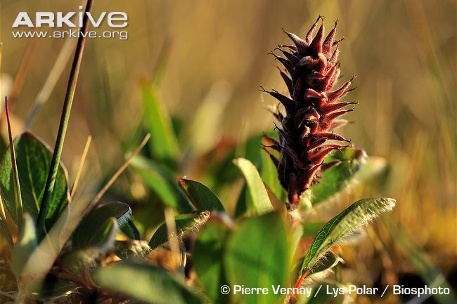
Arctic Willow

The Arctic willow (Salix arctica) is a low-growing shrub, which grows flat along the ground and usually grows in matches where the plants are clumped together. Not all Arctic Willows have the same appearance and size, with leaf shape and speed of growth known to be very different depending on exactly where it is growing.
The leaves of the Arctic willow are mainly oval-shaped, and have a smooth edges and a pointed tip. They are green and glossy on the top and pale grey-green on the underside. The Arctic willow produces long, cylindrical (sausage shaped) clusters of flowers, known as ‘catkins’, which contain either a male or female flower.
The female catkins are hairy and are usually between one and eight centimetres long. The male catkins are smaller, only growing up to four centimetres long. Both male and female catkins usually grow from the sides of the stems.
The stems of the Arctic willow are shiny and not hairy. They can vary in colour between yellow-brown, grey-brown or red-brown.
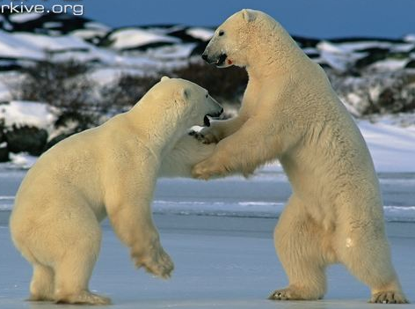
Polar Bear

The polar bear (Ursus maritimus) is the largest living land carnivore (meat eater), with adult males growing up to 2.6 metres in length. The polar bear, the most well-known of all bears, is immediately recognisable from the distinctive white colour of its thick fur.

The only unfurred parts of the body are the foot pads and the tip of its nose, which are black, revealing the dark colour of the skin underneath its fur.

The neck of the polar bear is longer than in other species of bears, and the elongated head has small ears. Polar bears have large strong limbs and huge forepaws which are used as paddles for swimming.

The toes are not webbed, but are excellent for walking on snow as they bear non-retractable claws which dig into the snow like ice-picks. The soles of the feet also have small projections and indents which act like suction cups and help this bear to walk on ice without slipping.

Females are about half the size of males. Polar bear cubs weigh up to 0.7 kilograms at birth. They look similar in appearance to adults, though they have much thinner fur.

Adaptations - RESEARCH
Explain how each animal and plant you have read about has adapted to survive in the habitat they live in.
Animal / Plant | Adaptations (features they have or things that they do) | Benefit (how it helps them survive)

Adaptations – DESIGNING MY OWN SPECIES
Name of my species…

My species’ habitat:___________________________
My Species Design:
Labelled diagram:
New habitat - would it
survive and why?

