Each day gets progressively harder. Do not skip a day as you will need the learning from the previous day to understand the day after – do them in the correct order. There are three challenges per day. Each one gets a little harder, so start with the first and work your way down. Don’t panic if you can’t do them all. Watch the video again and as an adult for help.

Monday: Division by chunking numbers (see Monday’s video on Maths with Parents) The children will demonstrate the ‘chunking method’ which you can use to help you solve the challenges below. Remember you can draw your place value counters!
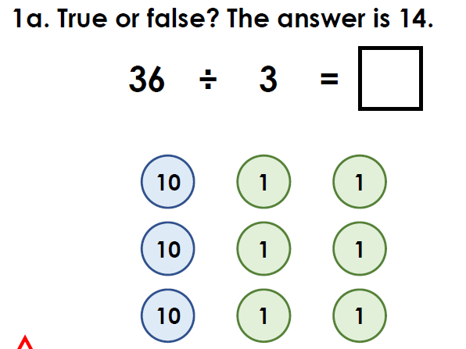

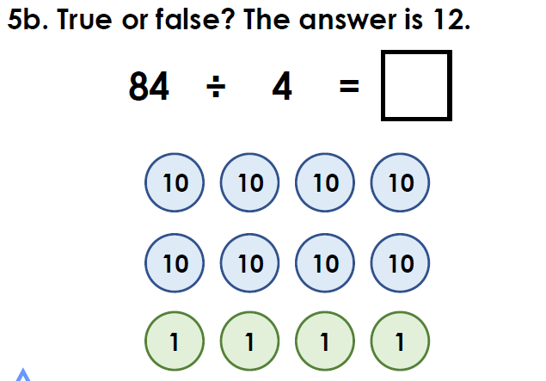

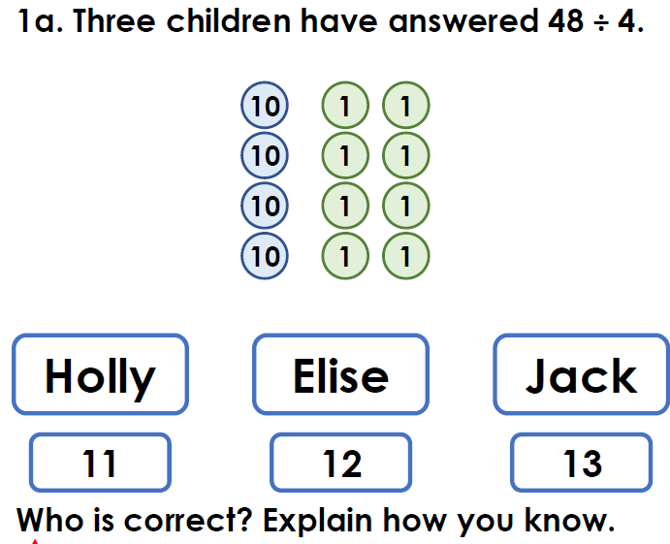

Tuesday: Division by partitioning (see Tuesday’s video on Maths with Parents) The children will demonstrate the ‘partitioning method’ which you can use to help you solve the challenges below.
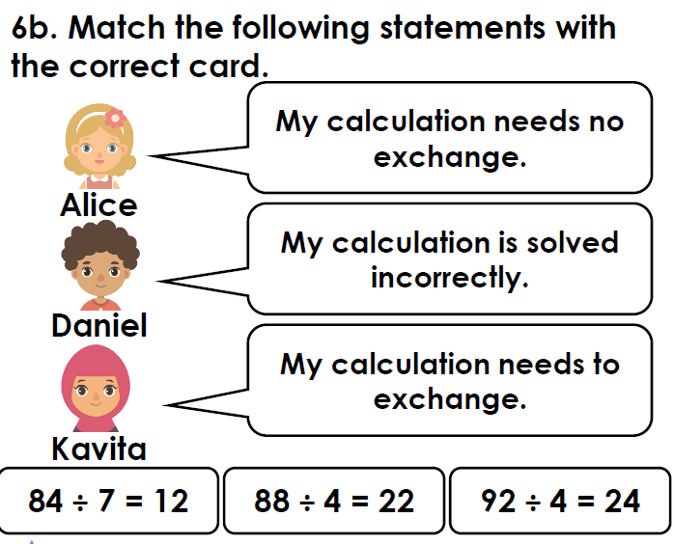

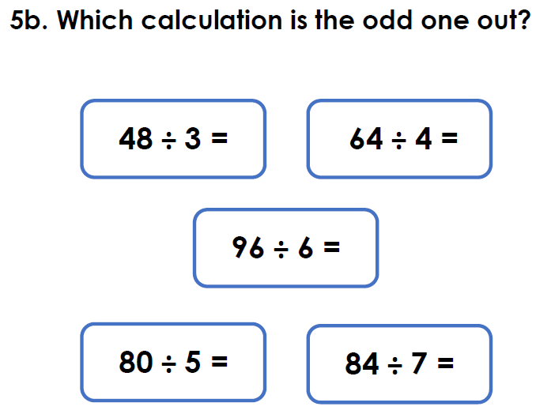

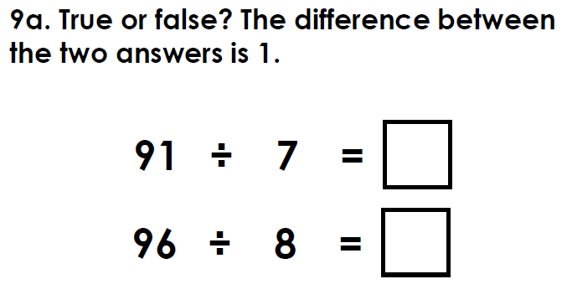

Wednesday: Using your 3 and 6 times tables (see Wednesday’s video on Maths with Parents) The children will demonstrate the how to use their knowledge of the 3 times table to help them with their 6 times table. Use this method to help you solve the challenges below.

- Practise your 3 and 6 times tables with an adult. Write them down. Draw arrays to help you find the answers. Can you spot any patterns between the 3 and 6 times table? (you’re so good at pattern spotting now!)
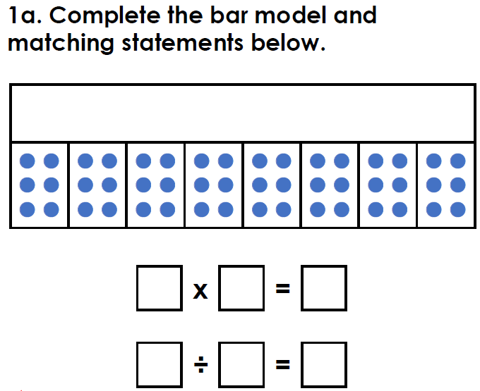

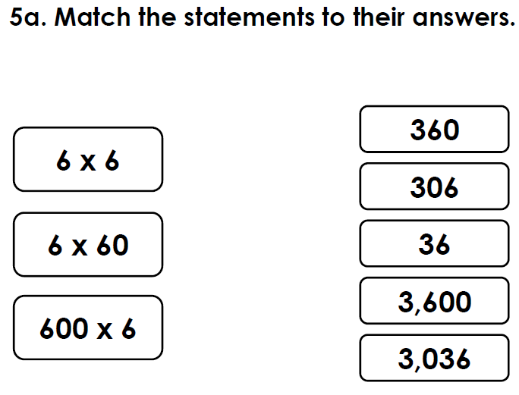

Can you spot the pattern to help you?
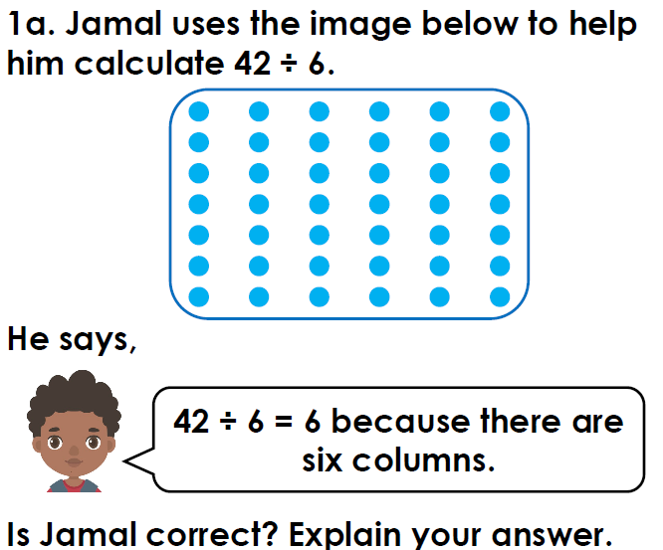

Thursday: Multiplication using a grid (see Thursday’s video on Maths with Parents) The children will demonstrate the how to use their knowledge of partitioning (Look back to Tuesday’s video if unsure on partitioning) to multiply using the grid method. Use this method to help you solve the challenges below.

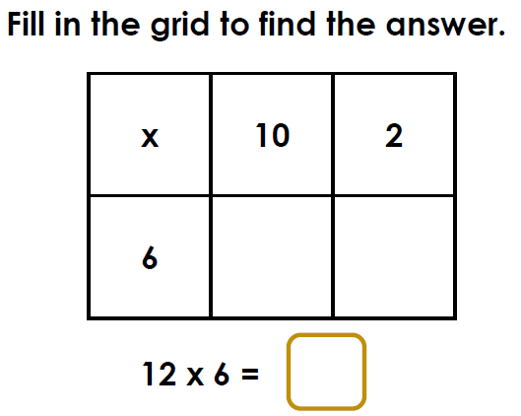

Now use the grid method to solve these:

14 x 2 =
24 x 3 =
36 x 4 =
72 x 8 =

!CHALLENGE!
Friday: Multiplication using a grid (see Friday’s video on Maths with Parents) The children will demonstrate the how to use their knowledge of partitioning and their knowledge of the grid method to multiply 2 digits by 2 digits. This is a trickier challenge that builds on the maths you will have done throughout the week, so only give it a go if you feel confident! Good luck

Example
23 x 22 = 506

x | 20 | 2
20 | 20 x 20 = 400 | 20 x 2 = 40
3 | 20 x 3 = 60 | 2 x 3 = 6

400 + 60 + 40 + 6 = 506

Your turn
21 x 32 =
34 x 55 =
67 x 41 =

