Year 3 Topic-Week 6: History

This half term you are going to be learning about the Stone Age! What do you know about the Stone Age already? What would you like to find out?

Activity 1: Write down 4 things you know already about the stone age, or that you think these pictures tell you.

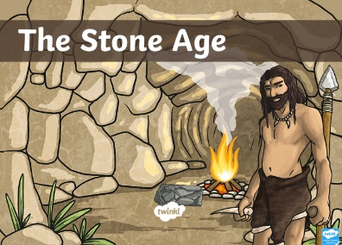
Activity 2: Write a list of at least 5 questions that you would like to find out about the Stone Age.
Don’t forget to use a range of question words e.g. what, why, how, can, did, which, who, would, when

Activity 3: Look at the Introduction to the Stone Age PowerPoint and see if you can answer any of your questions!



