Year 6 - Week 2 - Writing Tasks

Task 1: Read the blurb and make predictions.

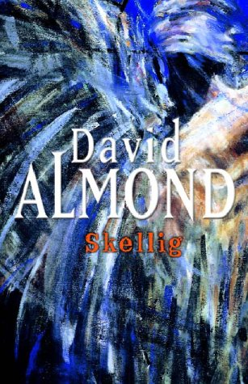

**Everything seemed to have been going wrong for Michael and his family since they moved into their new house: his baby sister had been taken ill, the house is a mess and his parents are tired and worried.**

**Then Michael makes a discovery in the crumbling garage at the end of their garden. Propped up against the wall, covered in spiders’ webs and dead flies, the creature seems to be alive. What or who it is, Michael doe not know, but he knows he must save it. With the help of his friend Mina, they carry the creature out into the light and then the magic begins…**

**Chapter 1 –** Why do you think the first chapter starts with the immediate discovery of ‘him’?

**Initial predictions**

**Plot:**

**Character(s):**

**Ending:**

**Chapter 3 – List seven verbs you can find in this chapter. Try to use the most interesting or exciting.**

**Chapter 2 –** Draw your idea of the inside of ‘the garage’. Make sure you pay attention to the description at the start of this chapter – label your drawing with descriptive language.