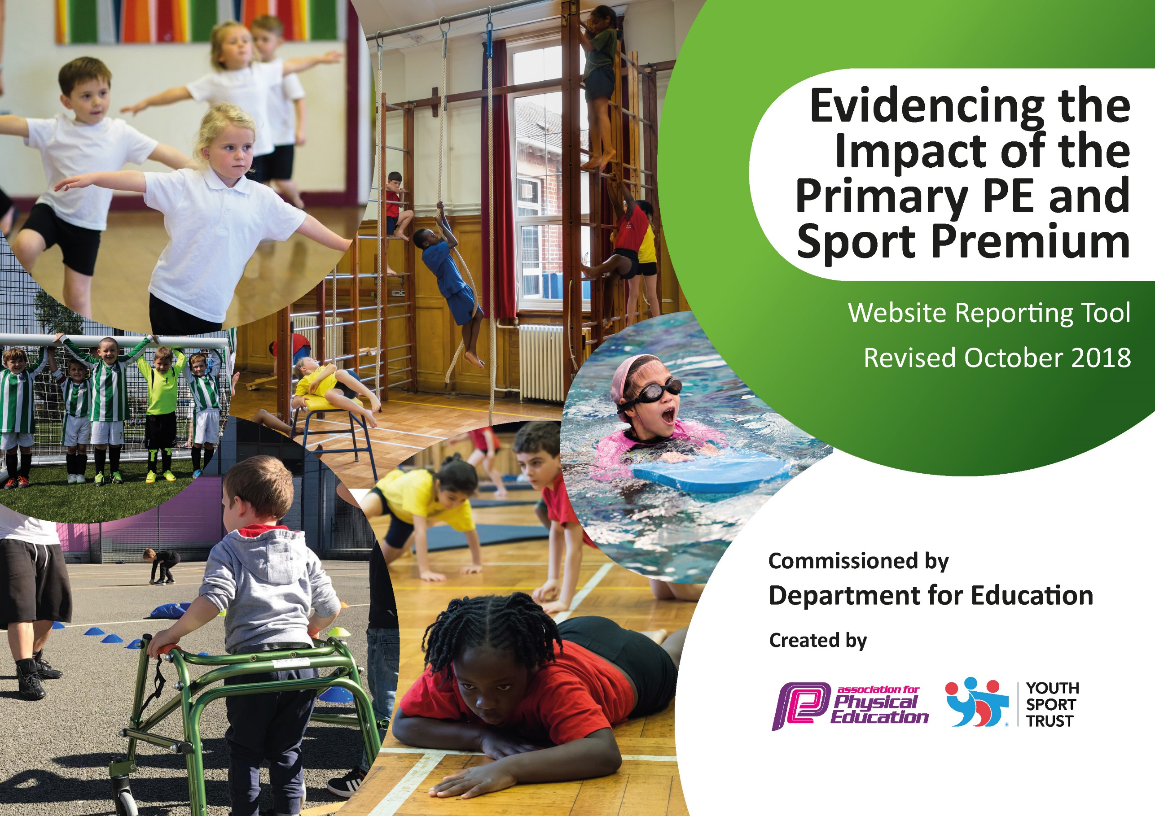
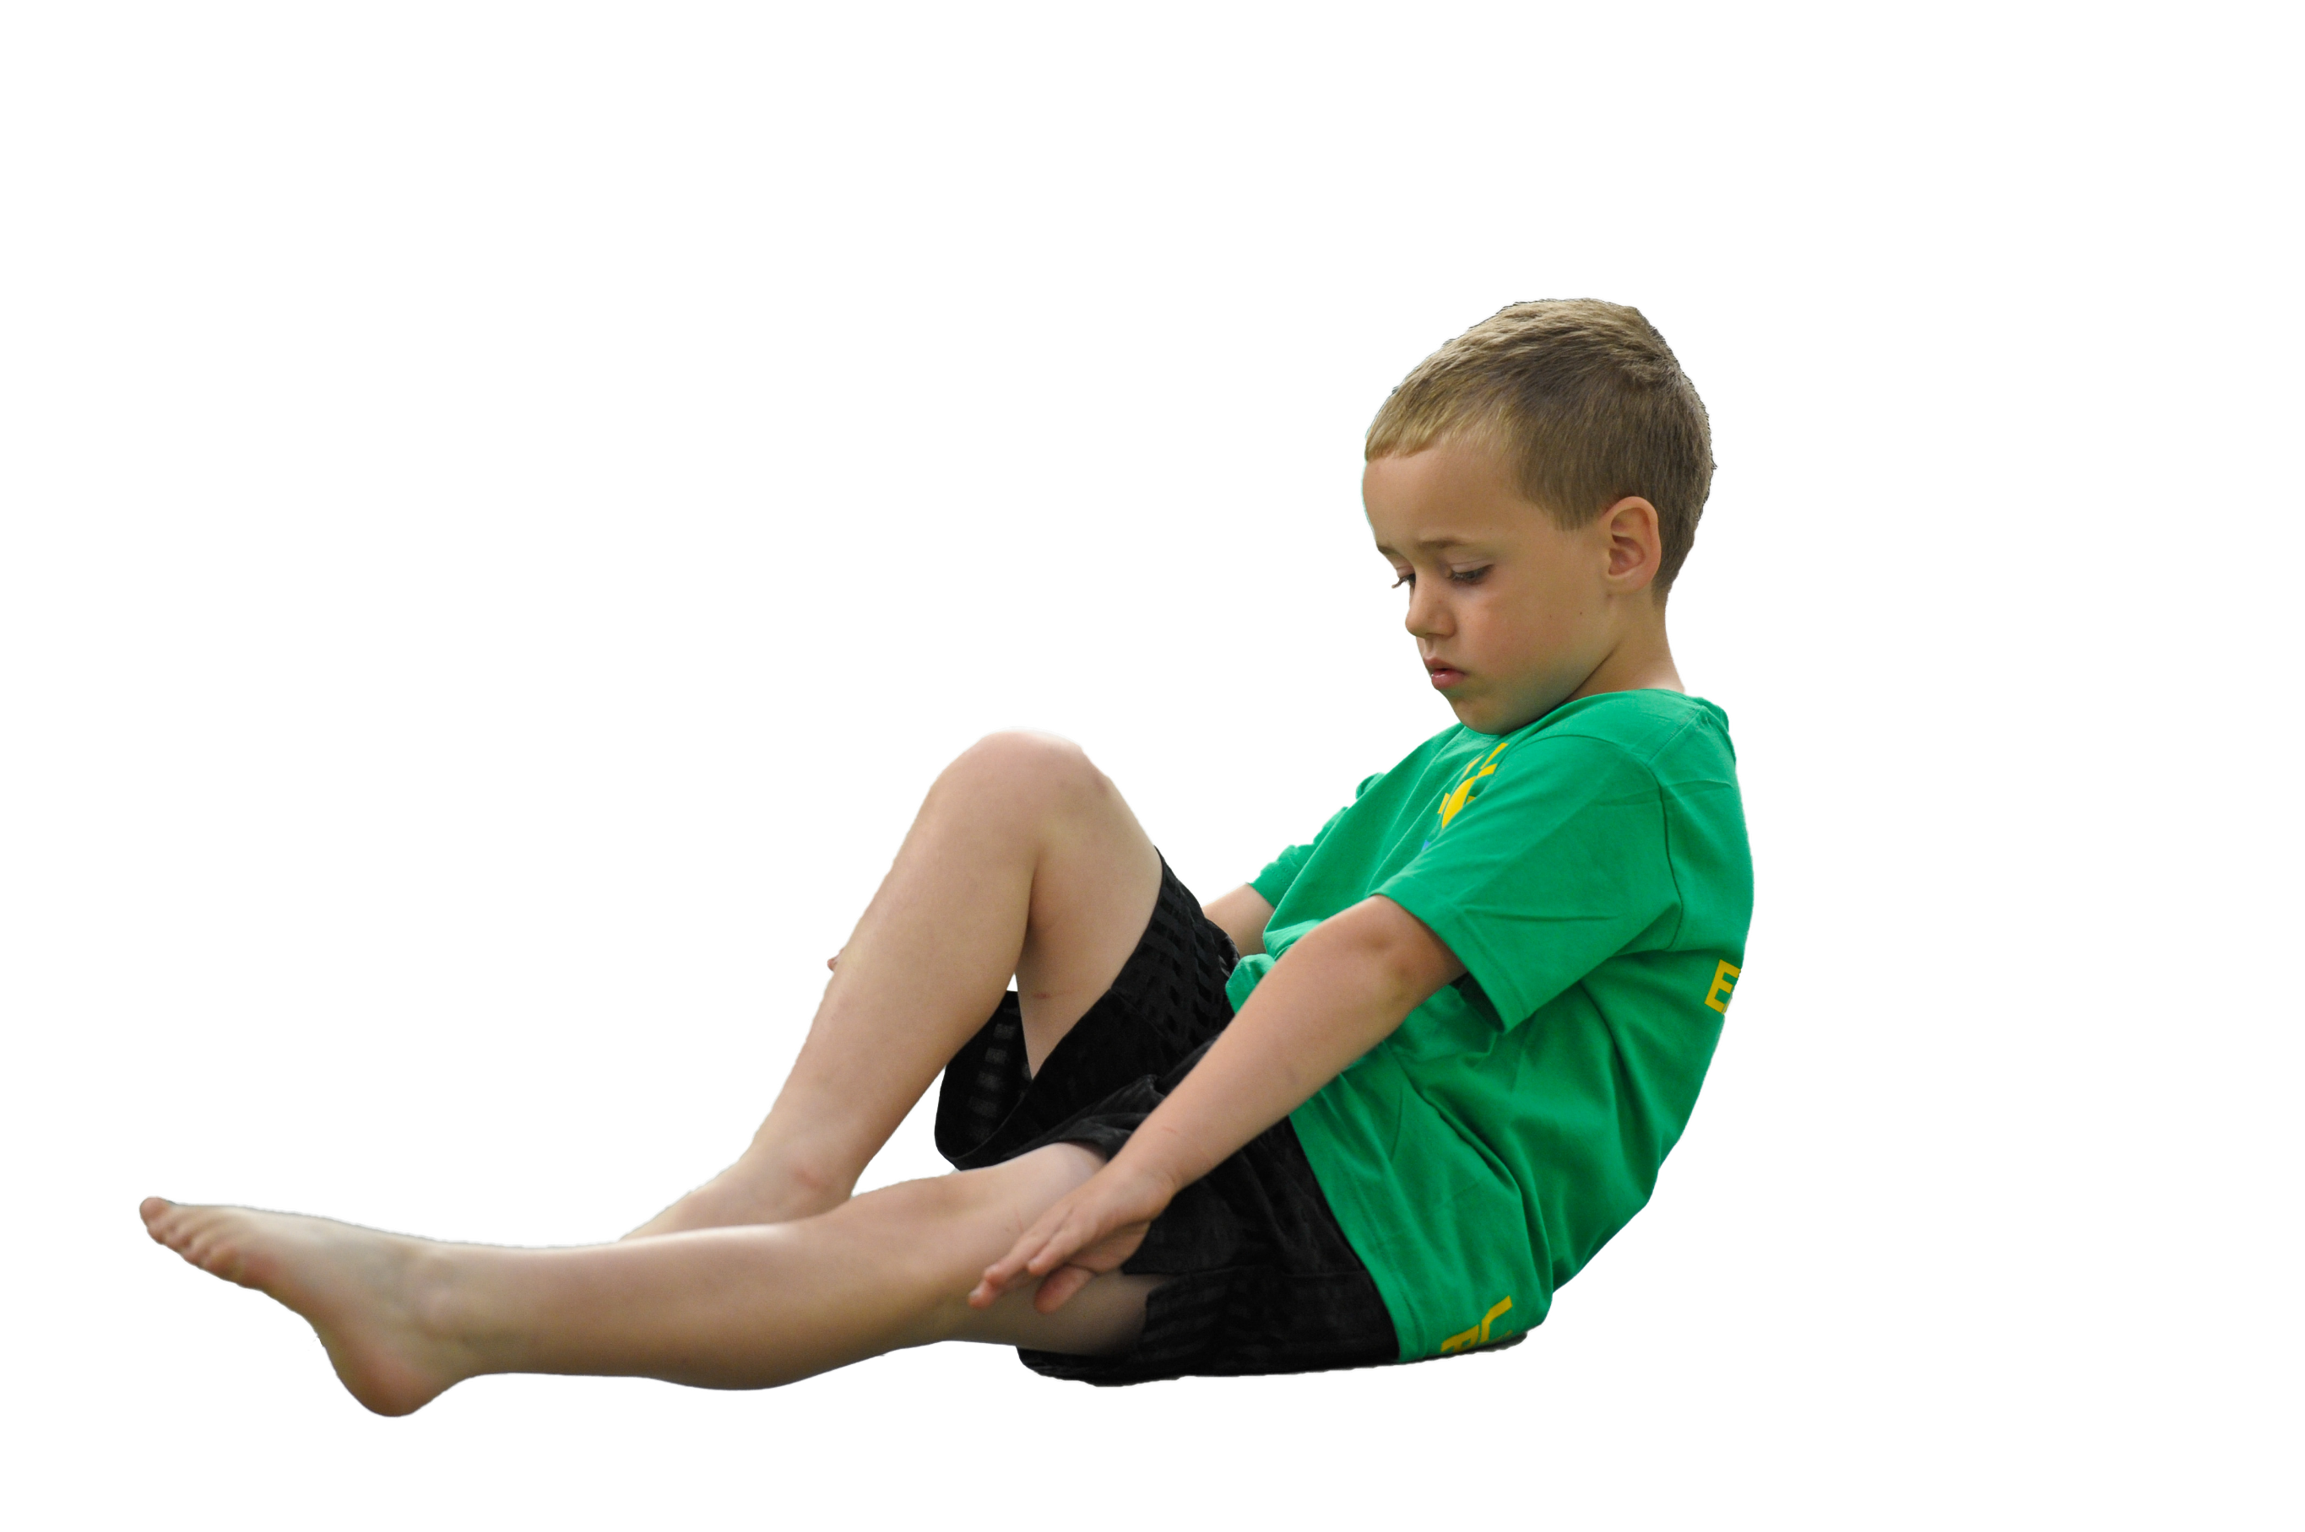
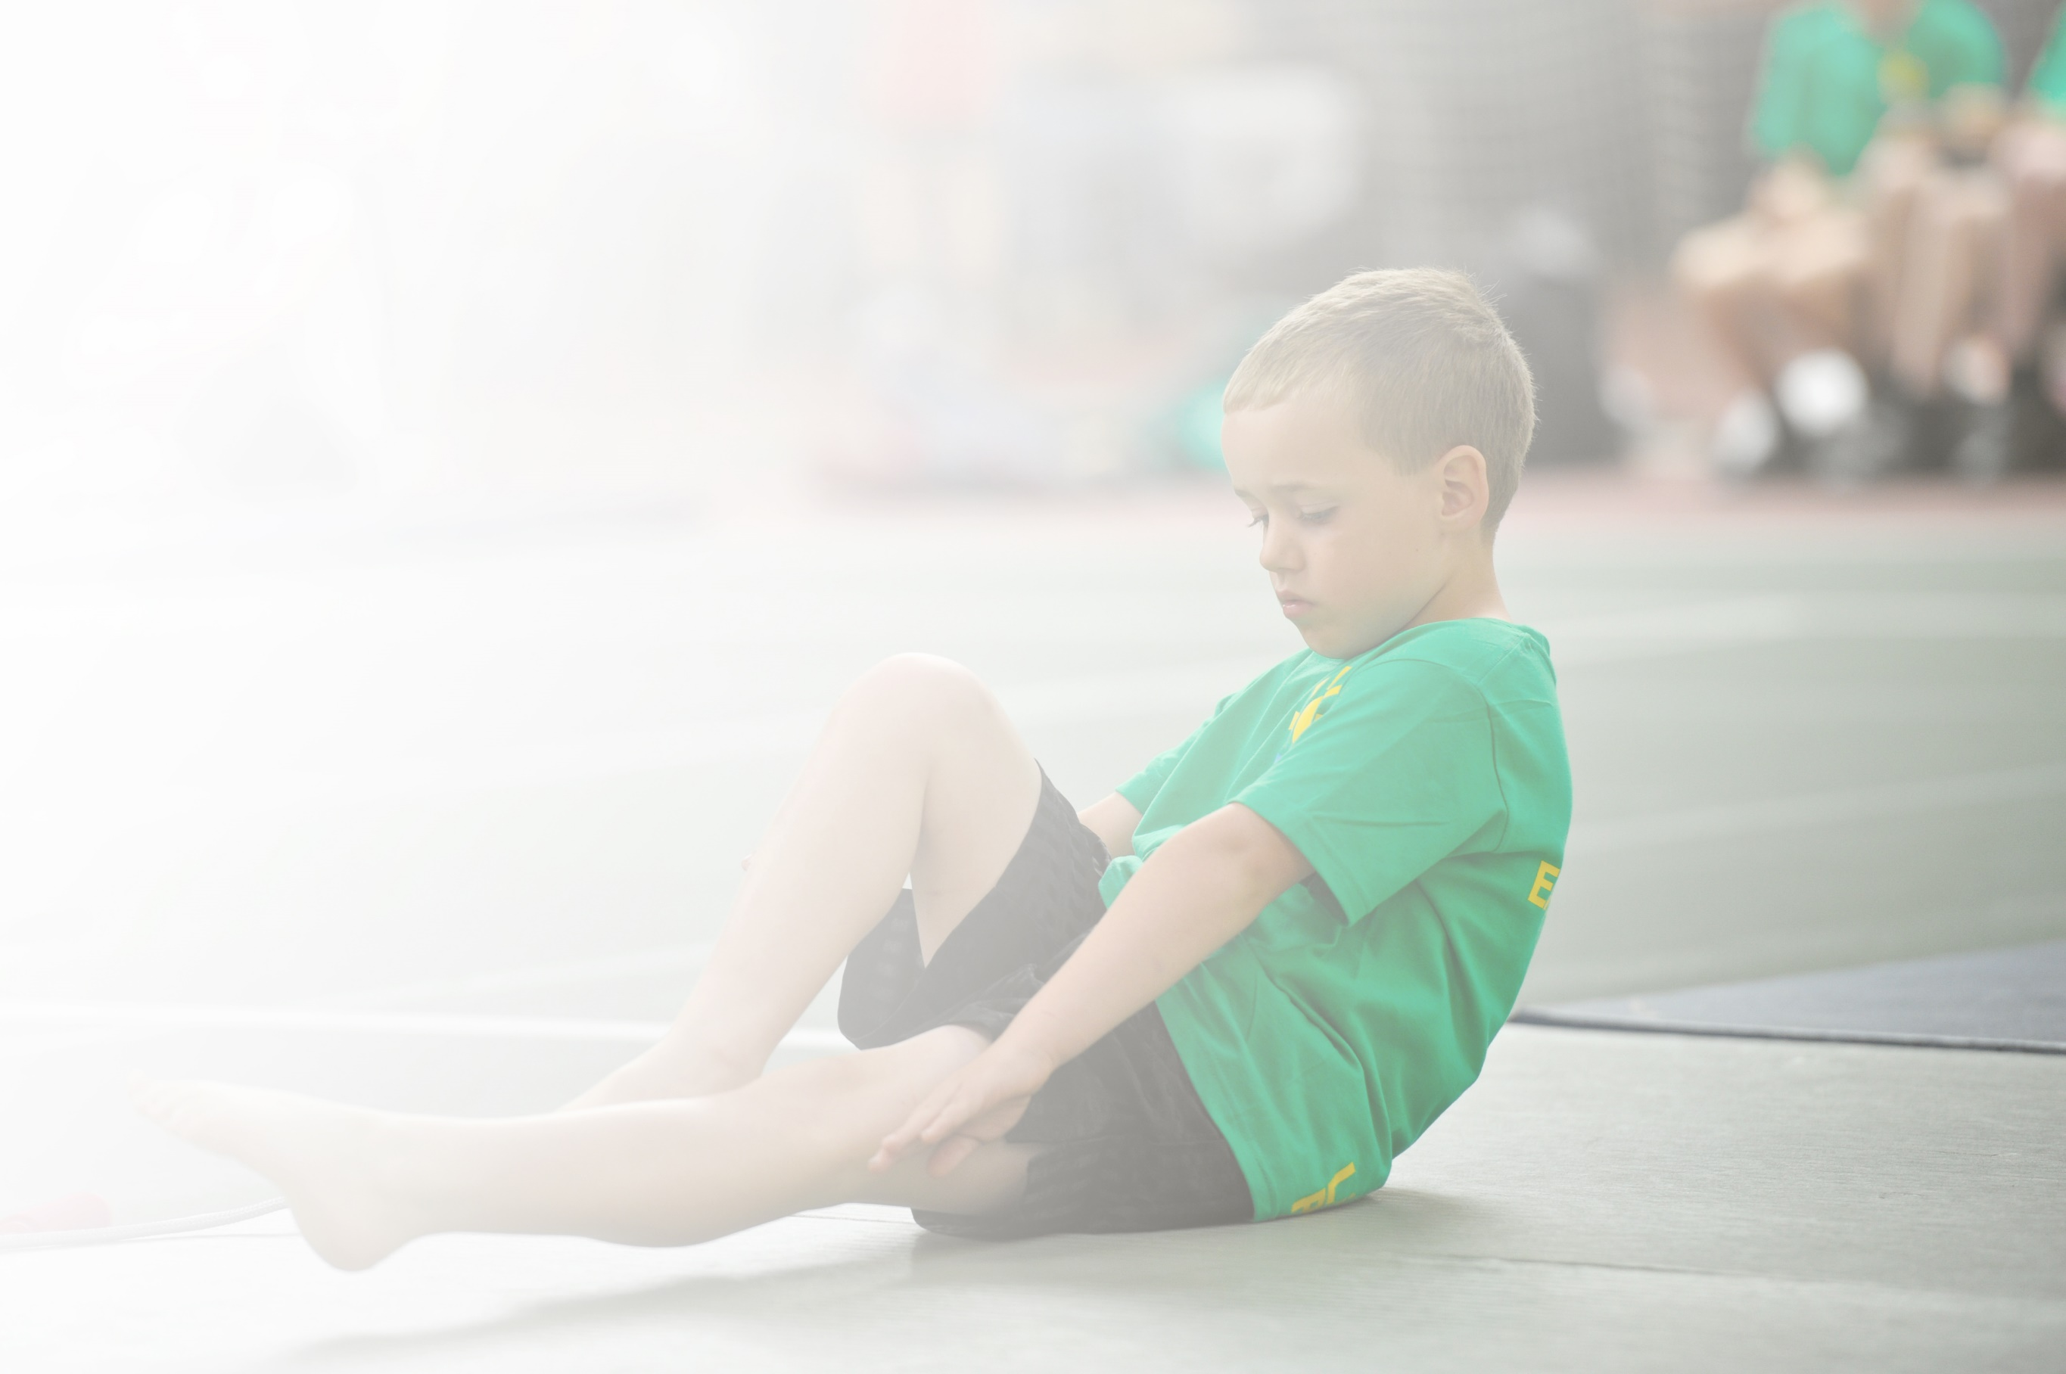
Schools must use the funding to make additional and sustainable improvements to the quality of Physical Education, Sport and Physical Activity (PESPA) they offer. This means that you should use the Primary PE and Sport Premium to:

- Develop or add to the PESPA activities that your school already offer
- Build capacity and capability within the school to ensure that improvements made now will benefit pupils joining the school in future years

Please visit gov.uk for the revised DfE guidance including the 5 key indicators across which schools should demonstrate an improvement. This document will help you to review your provision and to report
your spend. DfE encourages schools to use this template as an effective way of meeting the reporting requirements of the Primary PE and Sport Premium.

We recommend you start by reflecting on the impact of current provision and reviewing the previous
spend. Under the Ofsted Schools Inspection Framework, inspectors will assess how effectively leaders use the Primary PE and Sport Premium and measure its impact on outcomes for pupils, and how effectively governors hold them to account for this.

Schools are required to publish details of how they spend this funding as well as on the impact it has on pupils’ PE and sport participation and attainment by the end of the summer term or by 31 July 2019 at the
latest.
We recommend regularly updating the table and publishing it
on your website throughout the year, as evidence of your
ongoing review into how you are using the money to
secure maximum, sustainable impact. To see an
example of how to complete the table please
click HERE.

Support for review and reflection - considering the 5 key indicators from DfE, what development needs are a priority for your setting and your students now and why? Use the space below to reflect on previous spend, identify current need and priorities for the future.

Key achievements to date: | Areas for further improvement and baseline evidence of need:
The employment of a P.E coach has meant that the standard of P.E teaching has improved and all lessons are now good.  Teaching P.E through story telling has helped engage children in reception and key stage 1.  The introduction of the daily mile has ensured that more children are active every day.  There are a wide range of after school clubs available e.g. gymnastics, hockey, badminton, basketball, handball, Parkour and dance and there has been an increase in the children attending these.  There are a range of activities available to children at lunchtime and key stage pupils have been trained as playleaders to support with these activities.  Pupils have entered (and won) competitions in Southwark.  The school has worked alongside LPESSN to support G and T children.  Weekly celebrations of P.E achievements in celebration assemblies | Focus on improving the percentage of children meeting the national curriculum requirements for swimming  P.E coaches to support teaching staff in delivering P.E lessons.  Set up more intra-school competitions

Meeting national curriculum requirements for swimming and water safety | Please complete all of the below:
What percentage of your current Year 6 cohort swim competently, confidently and proficiently over a distance of at least 25 metres?  N.B. Even though your children may swim in another year please report on their attainment on leaving  primary school. | 60%
What percentage of your current Year 6 cohort use a range of strokes effectively [for example, front crawl, backstroke and breaststroke]? | 65%
What percentage of your current Year 6 cohort perform safe self-rescue in different water-based situations? | 0%
Schools can choose to use the Primary PE and Sport Premium to provide additional provision for swimming but this must be for activity over and above the national curriculum requirements. Have you used it in this way? | Yes

Action Plan and Budget Tracking
Capture your intended annual spend against the 5 key indicators. Clarify the success criteria and evidence of impact that you intend to measure to evaluate for students today and for the future.

Academic Year: 2018/19 | Total fund allocated: £ | Date Updated:
Key indicator 1: The engagement of all pupils in regular physical activity – Chief Medical Officer guidelines recommend that primary school children undertake at least 30 minutes of physical activity a day in school |  |  |  | Percentage of total allocation:
 |  |  |  | %
School focus with clarity on intended impact on pupils: | Actions to achieve: | Funding allocated: | Evidence and impact: | Sustainability and suggested next steps:
- All pupils to receive high quality teaching from trained coaches  - Pupil voice to show PE sessions are engaging, challenging, stimulating and accessible to all.  - Challenge for the more able is evident in lessons and in clubs.  - Develop opportunities for vulnerable groups to attend PE clubs, targeting them specifically.  - Introduce Yoga for targeted children  - Sport coaches at lunchtime organise games for the children  - Training sports leaders (year 4, 5 and 6 pupils)  - Membership of London P.E network- participate in competitions  - Introduce the daily mile  - Trained coached to support the running of activities at lunchtime- children to participate in cricket, tennis, football, badminton, catching games etc | P.E coaches continue the running of:  Multi-skills  Dance club, Judo, Hockey, Basketball, Gymnastic, Badminton,Parkour  Football clubs aimed at children who are vulnerable to not attending  Develop opportunities for vulnerable groups to attend PE clubs and participate in activities at lunchtime- targeting them specifically.  Yoga for targeted children with (6 per year group and for 8 weeks):  - Poor body awareness and core strength  - Poor concentration and focus  - Low self-esteem  Children will be involved in physical activity for at least 30 minutes per day – daily mile and activities at lunchtime  Year 4,5 and 6 children will develop their leadership skills and support their peers in participating.  All children are given the opportunity to participate in sports competitions- sports day and through the LPESSN group. | £  Coach salary  Coaches to run  £500 per day  £4000 – initial investment and then teacher to take over for the 2019-2020 academic year.  LPESSN membership | Children will receive high quality coaching that will encourage them to par take in an active and healthy lifestyle.  Children will experience different sports through clubs and engage in at least 30 minutes of physical activity a day.  Target children will show an increase in self-confidence and body control  There has been a significant improvement in the attendance of sporting extra-curricular activities through the engagement of pupils during lesson time  The introduction of additional sporting activities during lunch time to encourage active play has increased opportunities to participate in physical activity outside of structured lessons. | 42%  1 coach and 2 apprentices employed by the school. Next steps to provide more training for teachers and support them in delivering P.E lessons.  20%- teacher has taken over running this provision in a space that is free to hire so ongoing costs are free.  Year 4 and 5 pupils to continue to support play at lunchtimes- P.E coach to train year 4 pupils.
Key indicator 2: The profile of PESSPA being raised across the school as a tool for whole school improvement |  |  |  | Percentage of total allocation:
 |  |  |  | %
School focus with clarity on intended impact on pupils: | Actions to achieve: | Funding allocated: | Evidence and impact: | Sustainability and suggested next steps:
- Invite a local football team in to speak to children in assembly  - Celebrate children success- include these in the school newsletter and displaying newspaper clippings.  - Noticeboards with the sports on offer.  - Weekly P.E award to celebrate importance of participation in sport  - Sportsmanship awards during sports competitions  - Pupils to have option to participate in daily mile at break times | Information on club times and competitions to be on display in entrance hall.  To inspire children to want to be involved in these assemblies by ensuring these celebrations happen every week.  Medals presented to celebrate these children.  Encourage children to participate in physical activity at playtimes. Year 6 children to help with the organisation of daily mile and coach to supervise. | P.E Coaches to run | To develop the aspirations of children and the opportunity to meet professional sports people.  Children will feel proud to have their achievements recognised.  Encourage children that they wish to receive rewards in assemblies and have a positive impact on their self-esteem.  Children are rewarded for resilience and determinations- this will encourage future participation. | 42%  1 coach and 2 apprentices employed by the school. Next steps to provide more training for teachers and support them in delivering P.E lessons.  Continue to celebrate P.E star of the week and achievements in newsletters.  To continue to develop relationships with local football teams to encourage aspirations.

Key indicator 3: Increased confidence, knowledge and skills of all staff in teaching PE and sport |  |  |  | Percentage of total allocation:
 |  |  |  | %
School focus with clarity on intended  impact on pupils: | Actions to achieve: | Funding  allocated: | Evidence and impact: | Sustainability and suggested  next steps:
- Continue to work with London School P.E Network to engage in whole school training (Inset)  - Identify training needs of staff and send them on the relevant courses. | Bespoke support targeted to improve areas which are important to our school including professional development and health and well-being. | £5500  LPESSN membership | Increased confidence, knowledge and skills of all staff that teach PE. Broader range of sports and activities offered to all pupils delivered by a more confident leader. Increase quality of teaching and learning. | 25%  Provides access to CPD and competitions. Review before next year and decide if coaches can run a similar provision.
Key indicator 4: Broader experience of a range of sports and activities offered to all pupils |  |  |  | Percentage of total allocation:
 |  |  |  | %
School focus with clarity on intended  impact on pupils: | Actions to achieve: | Funding  allocated: | Evidence and impact: | Sustainability and suggested  next steps:
Continue to offer a wider range of activities both within and outside the curriculum in order to get more pupils involved.  Additional achievements:  Additional swimming  To ensure all existing swimmers increase their attainment by 10 metres thus increasing their confidence in water.  All remaining non swimmers achieve 25 metres thus meeting the statutory requirements of the national curriculum for PE | Pupil voice to understand the activities pupils would like to participate in.  Continue the intense week swimming offer for Year 5 children.  Work with local swimming pools to find an appropriate location and skilled teacher for swimming.  Ensure remaining year 6 pupils are receiving swimming interventions | Coaches to provide this  £1600 | Introduction of new sporting clubs, daily mile and a range of activities at lunch time.  At the end of year 5  16% of children were achieving the end of Key Stage 2 requirements. The aim is to increase this to 70%.  At the end of year 5 79% of children were non swimmers. Of these 93% were achieving the end of KS1 requirements.  Desired target for the intervention is for:  60% of pupils can swim 25 metres at Year 6 using a range of strokes.  40% of pupils can swim competently, confidently and proficiently over a distance of 25m using a range of strokes.  100% of pupils increased their distance swimming by 10 metres.  What was actually achieved:  65% of pupils can swim 25 metres at Year 6 using a range of strokes.  60% of pupils can swim competently, confidently and proficiently over a distance of 25m using a range of strokes. | From year 1-6 pupils experience 14 different sports.  8%  Swimming provision provided by the local authority to be reviewed.  60% of children are now able to swim 25m after this intervention. This provision will need to be continued next year.  .
Key indicator 5: Increased participation in competitive sport |  |  |  | Percentage of total allocation:
 |  |  |  | %
School focus with clarity on intended  impact on pupils: | Actions to achieve: | Funding  allocated: | Evidence and impact: | Sustainability and suggested  next steps:
- Enter dance festival against other Southwark schools  - Pupils to enter local and international Judo competitions  - Engage more girls in inter/intra school teams  - Engagement with The PE & School Sports Network | Participate competitions on offer from LPESSN and sign up for these.  Sports coach to run lunchtime training sessions for year 5 and 6 girls.  Year 5 and 6 football team to participate in matches. | LPESSN membership  £1000 on equipment | A range of pupils to engage in competitive sports. This will support pupils in develop confidence and engage them in a healthy lifestyle.  Equipment to enable pupils to develop skills to enter a wider range of competitions.  More girls are willing to participate in PE with positive attitudes.  Children to take part in local sports competition and events with other local primary schools  An increase in entering inter school competition has allowed pupils to have more access to competitive sport. | 5% on equipment. Provides children with the opportunities to experience different sports and develop the skills to compete.

